VPC TASKS
- Create VPC with 2 private and 2 public subnets.
STEP 1: Login to your aws account and search for VPC option and select option
And select add vpc to add vpc then add the details and proceed
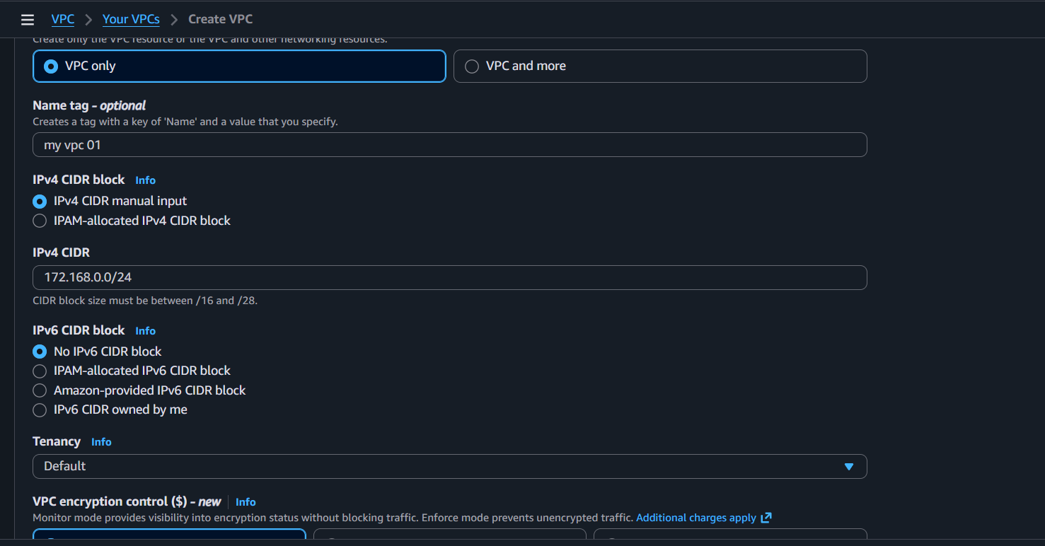
Then select the option create vpc to create Your vpc
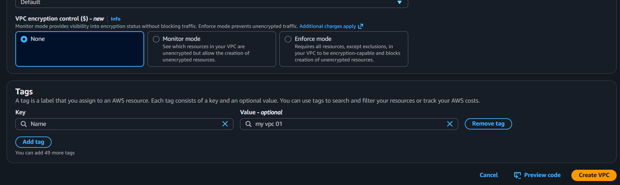
Your vpc has been created verify the information
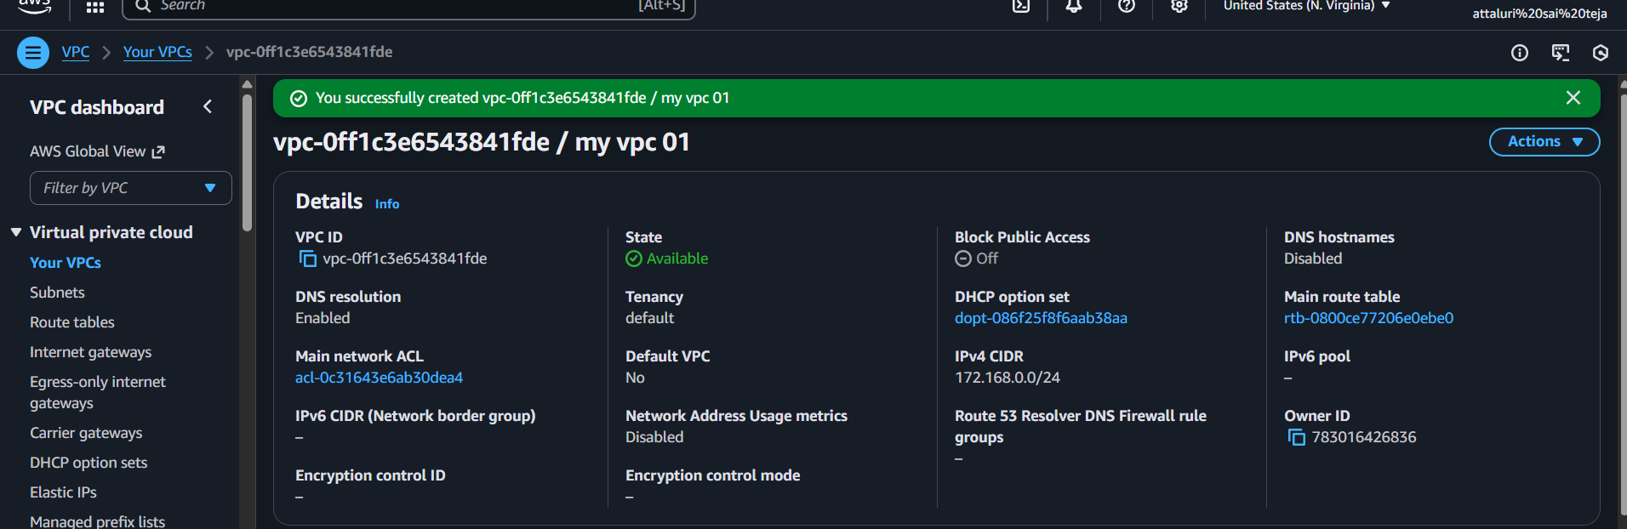
Then select the option that Subnets in vpc section and select create subnet located on right corner
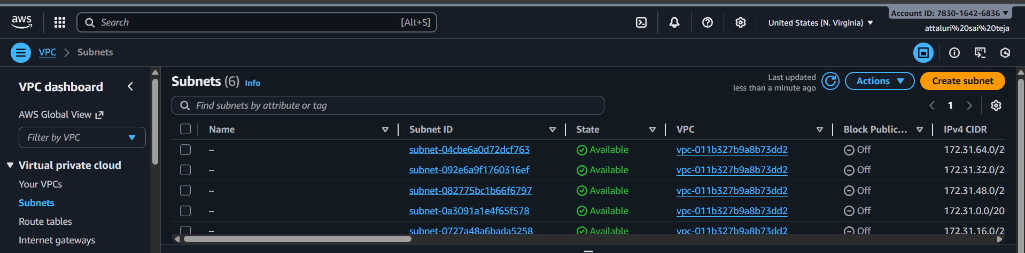
Add the names according to you and ip address with out overlapping one to each
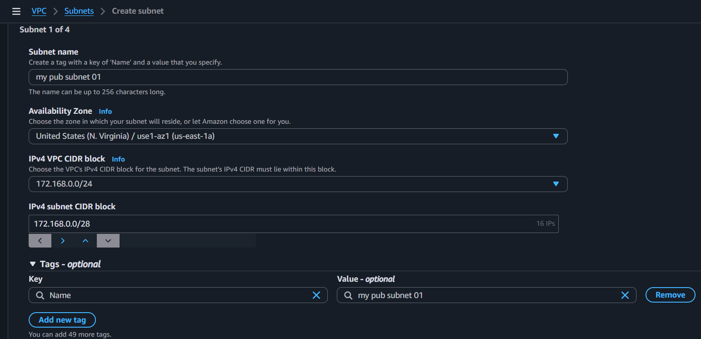
Then select option to add another subnet to create multiple subnets
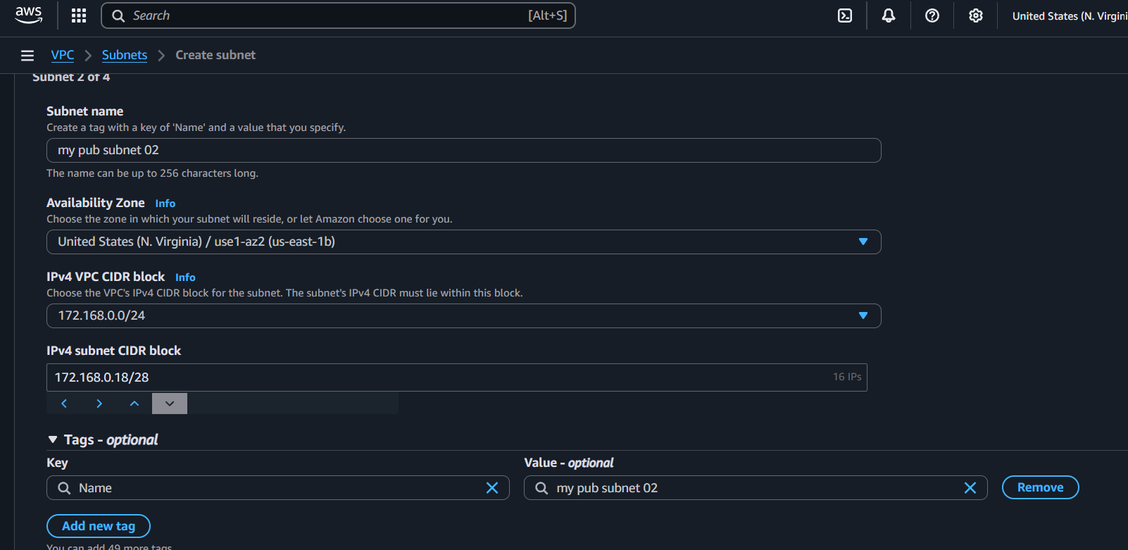

Same process for private ips also
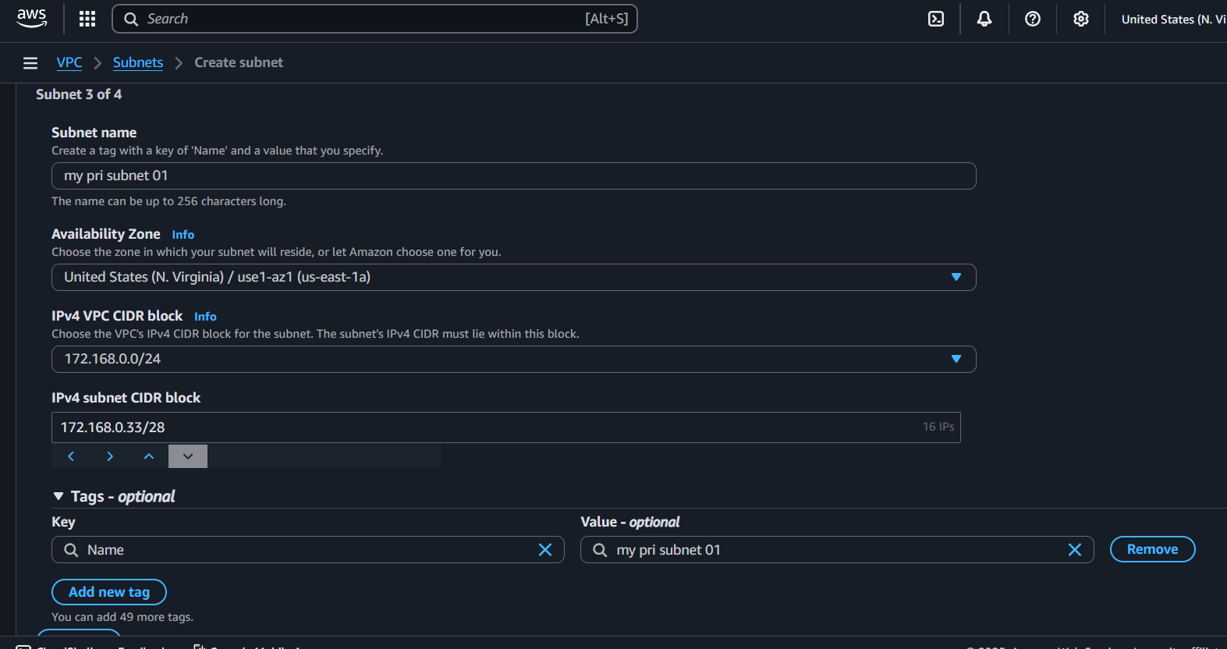
Give names accordingly to Identify which public and private subnets
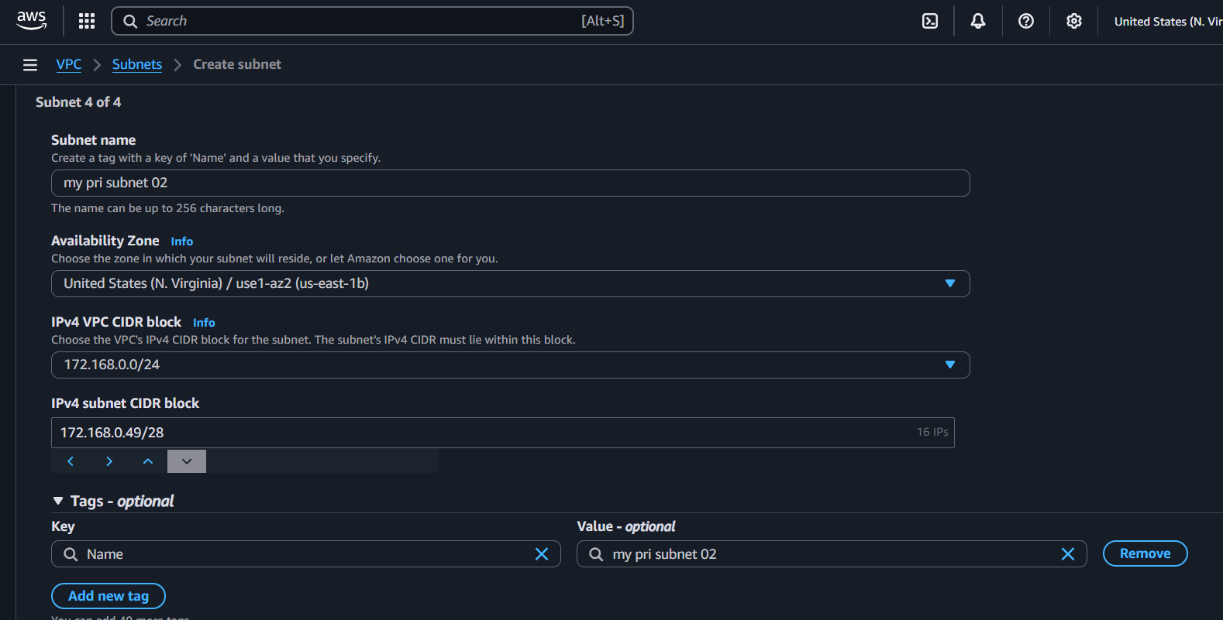
Then select the option Done to create
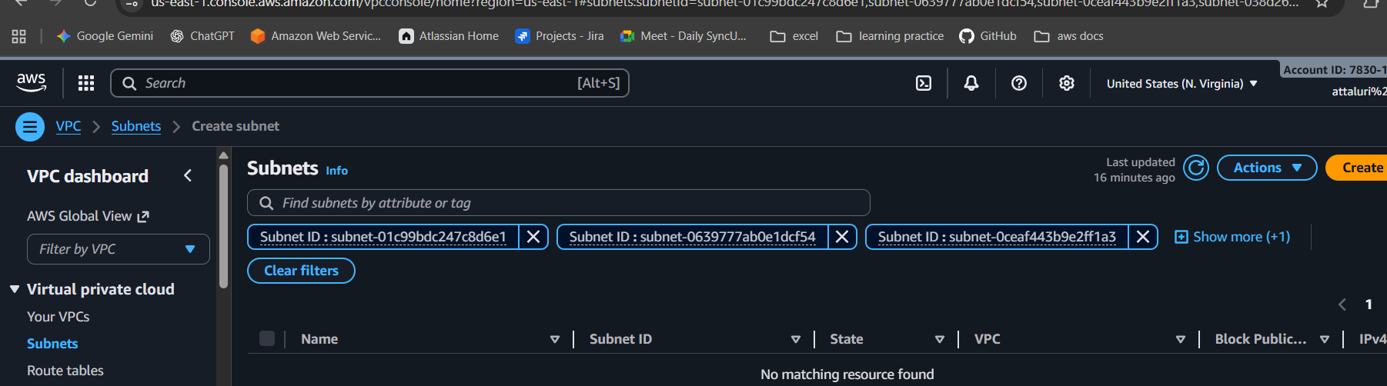
You will be listed With your subnets
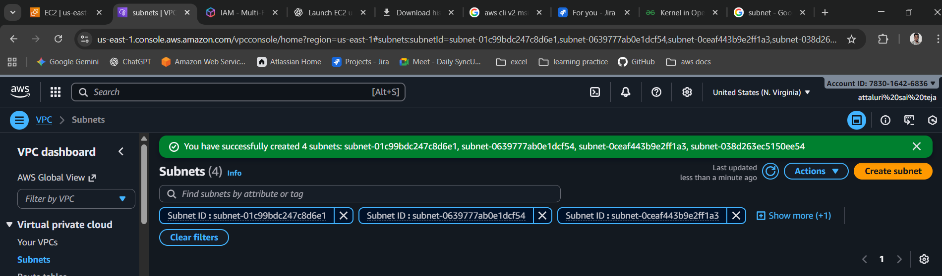
Select subnets option to list
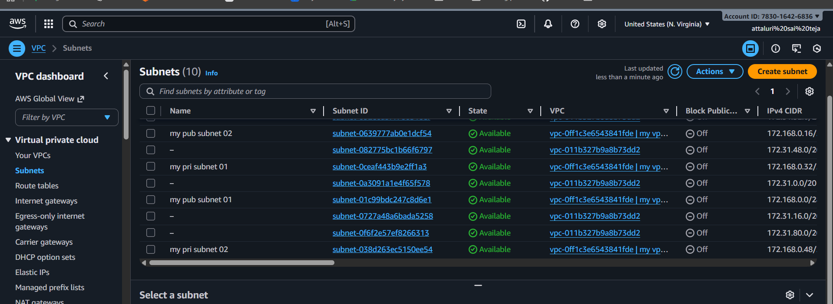
You can see a flow map /chart in Your vpc’s
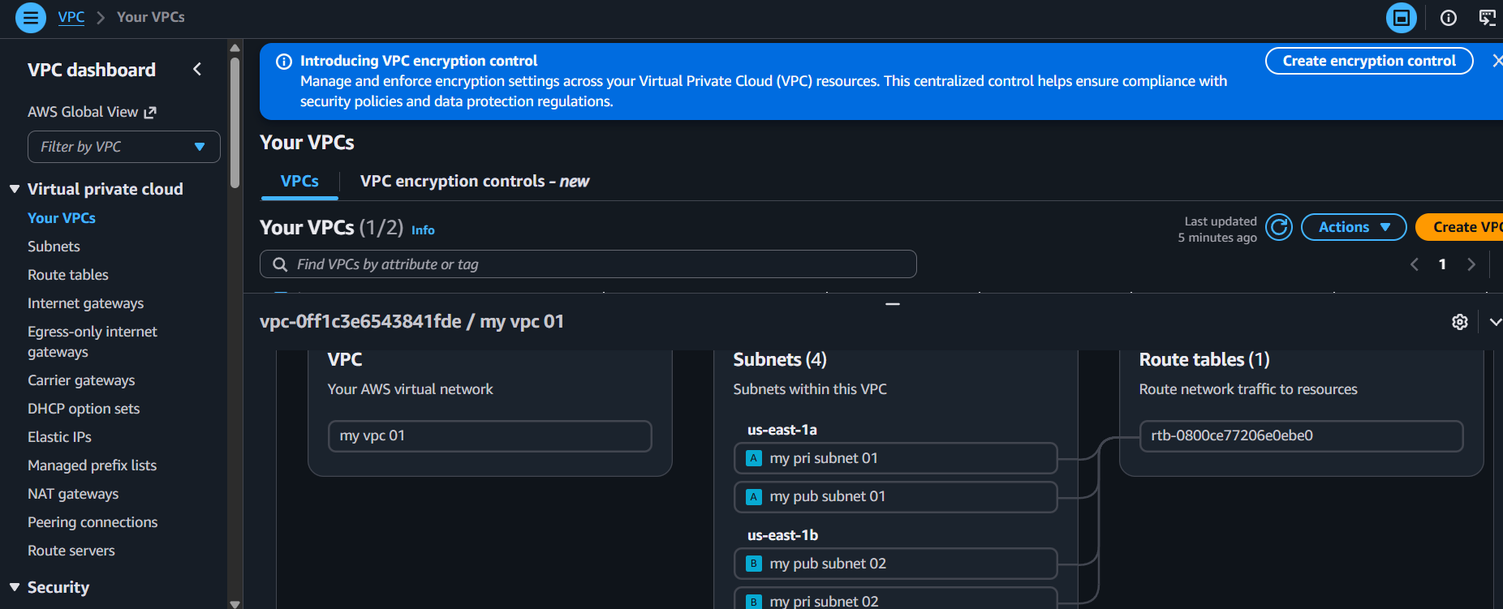

Enable DNS Hostname in VPC.
Navigate to vpc and select your vpc and click on actions tab
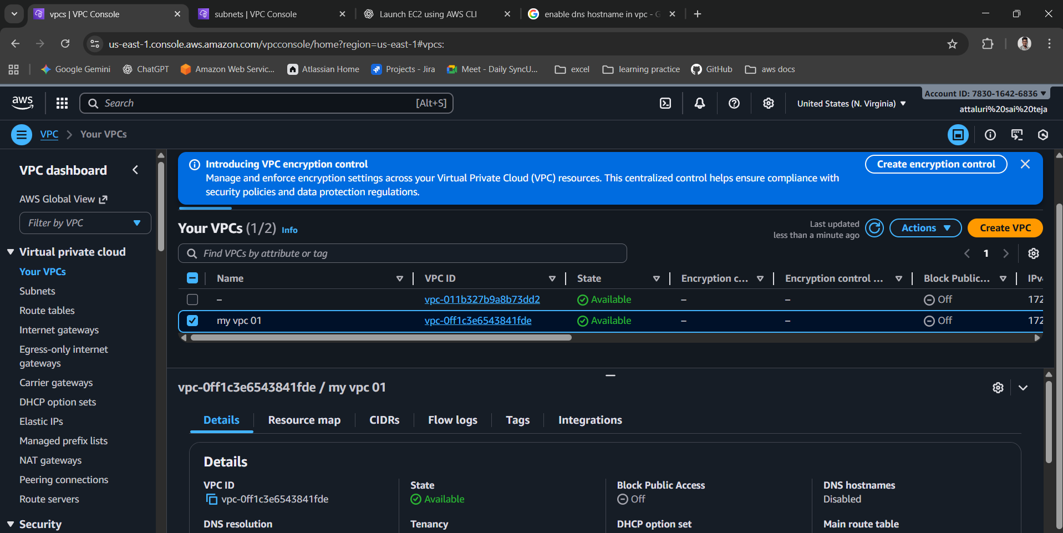
Select the option to view the settings
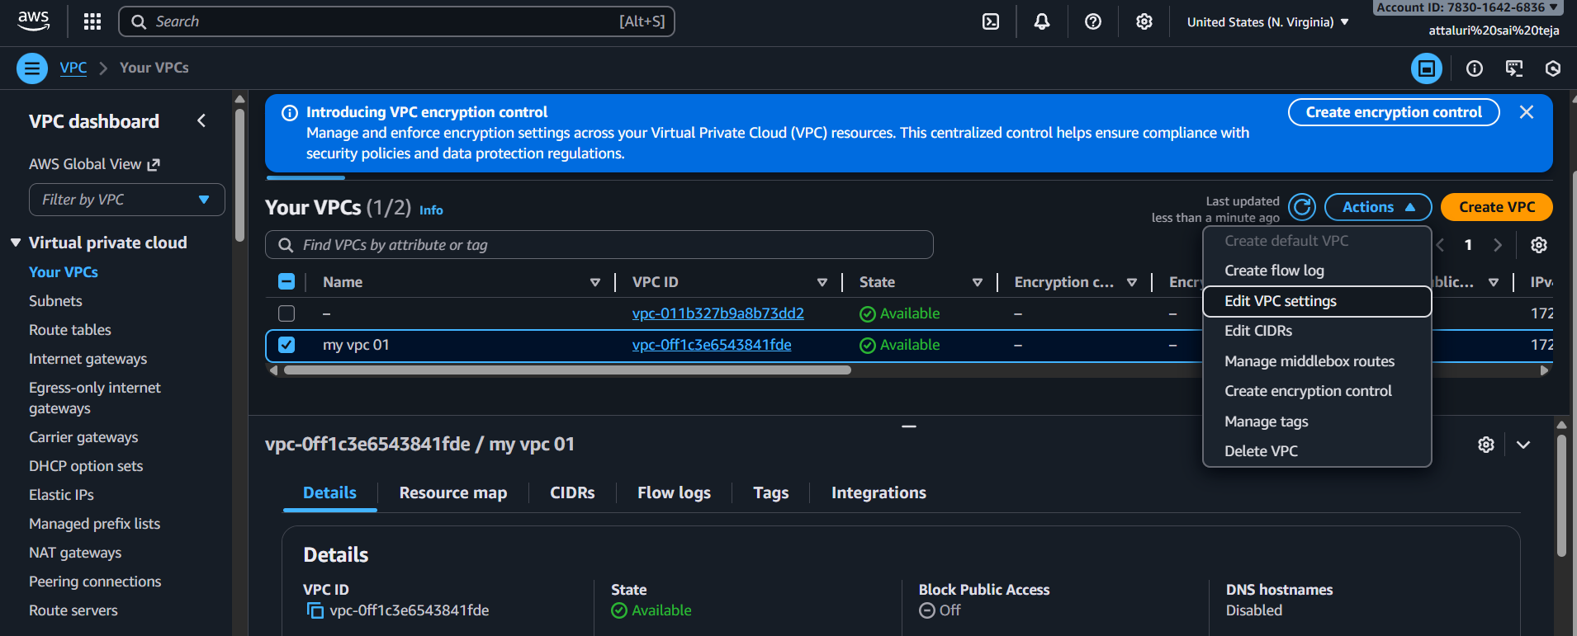
Enable the DNS Hostnames by clicking the check box and save
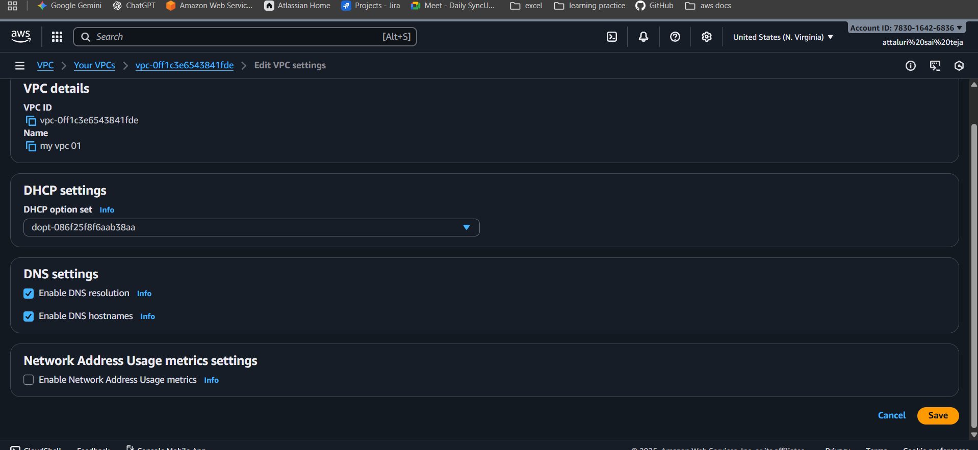
You Have enabled the DNS Hostname as you can see in below picture
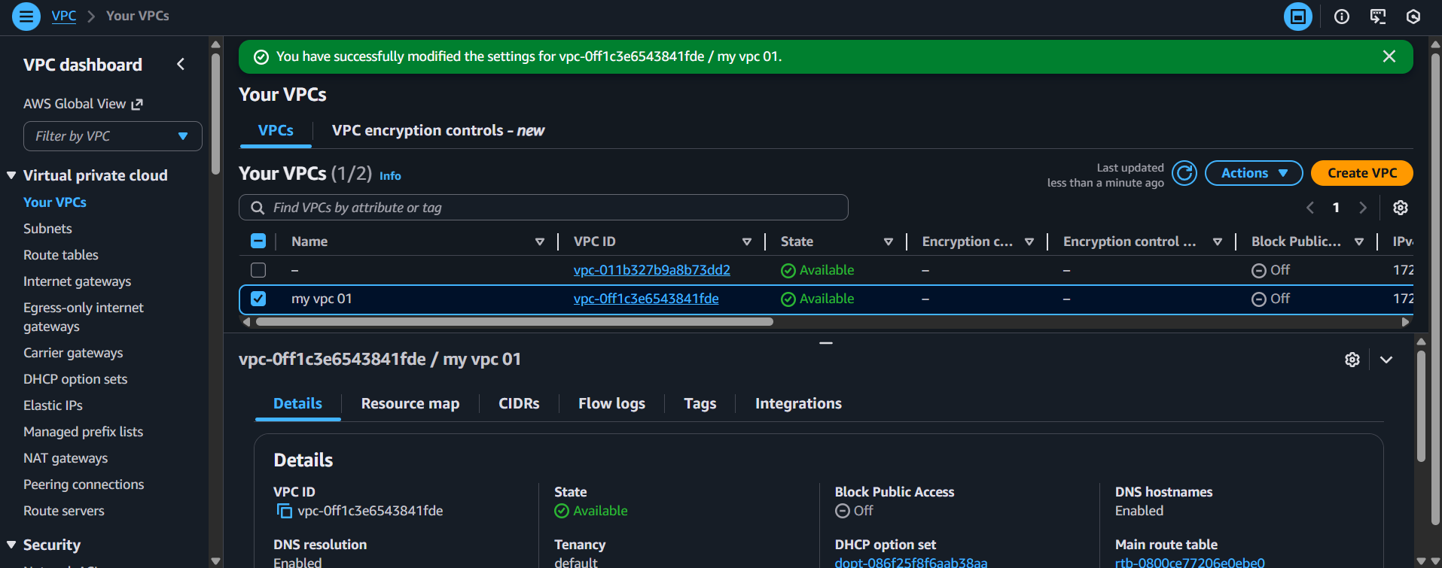

Enable Auto Assign Public IP in 2 public subnets.
You can Navigate to Subnets inside VPC then select a public subnet
If you check Auto assign public ipv4 address is Selected as no
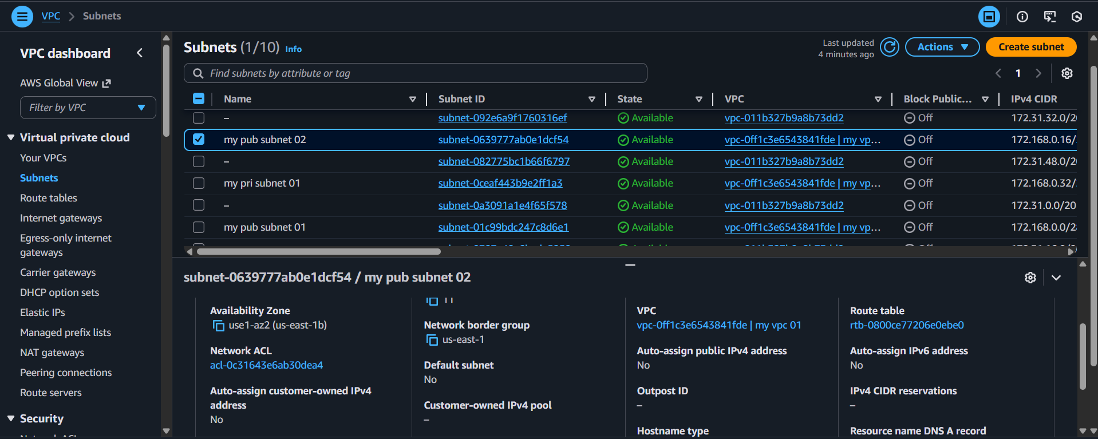
Access the Actions tab and select subnet settings
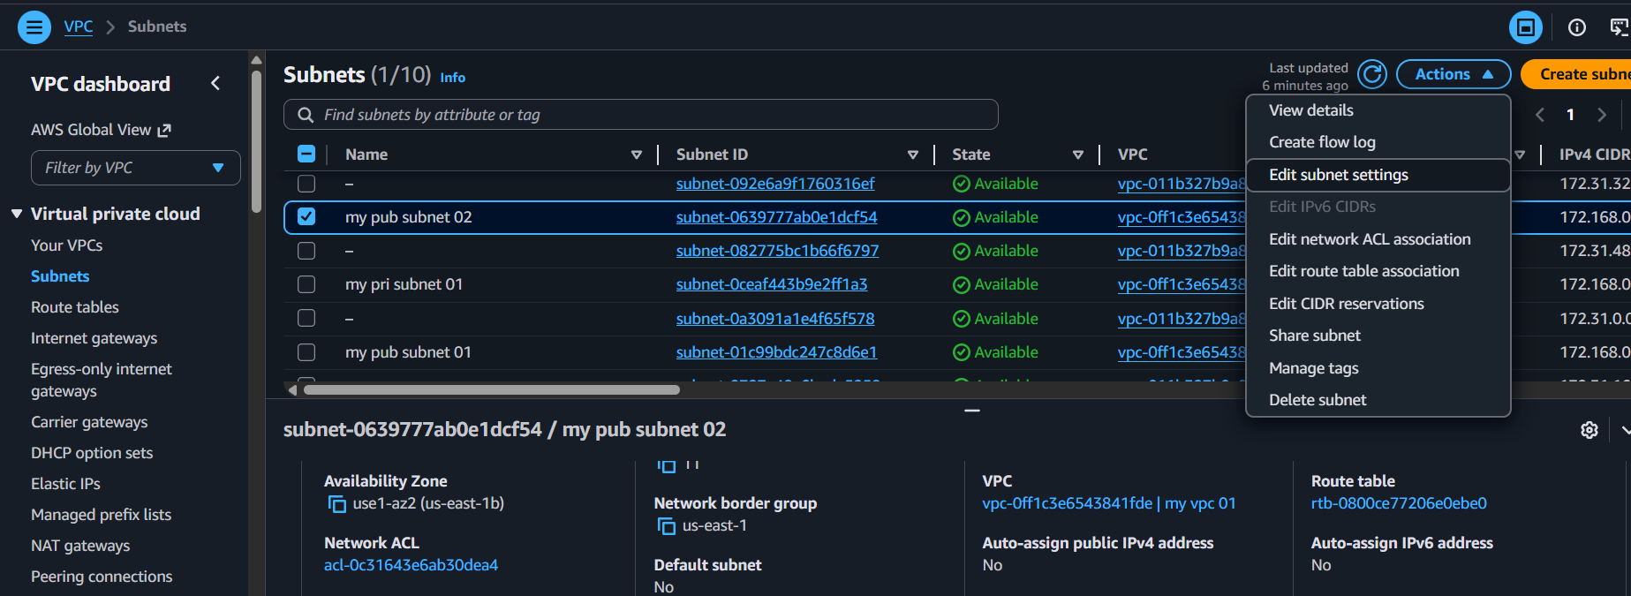
Enable the auto assign public ipv4 public address by clicking in check box
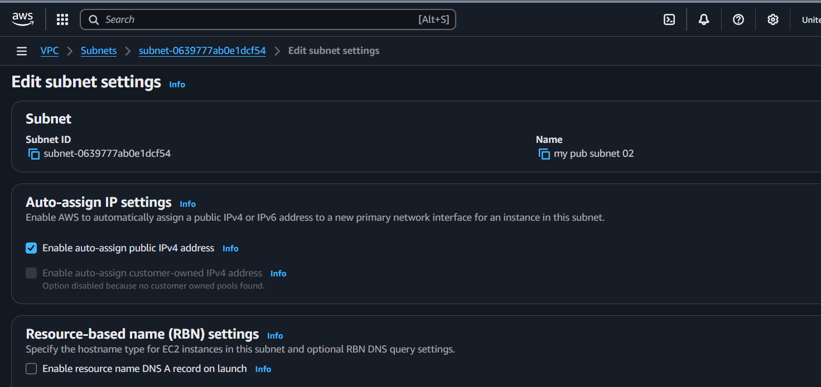
Then save to apply the changes
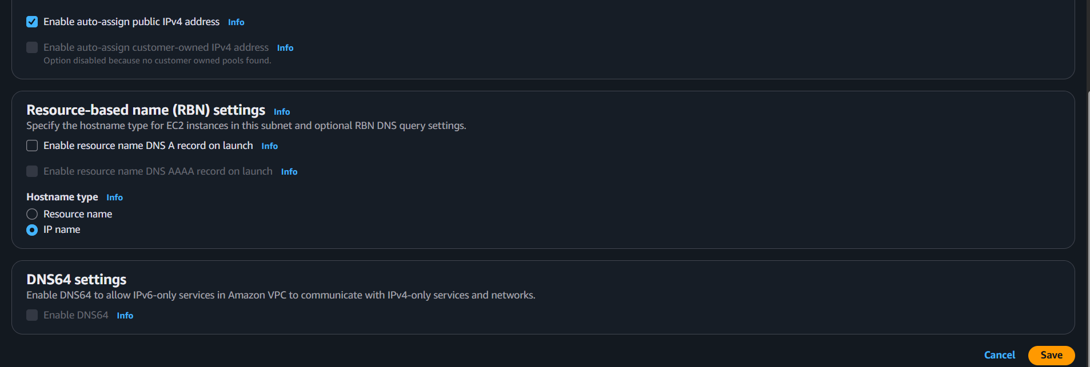
You successfully applied the changes to auto allow ipv4 address
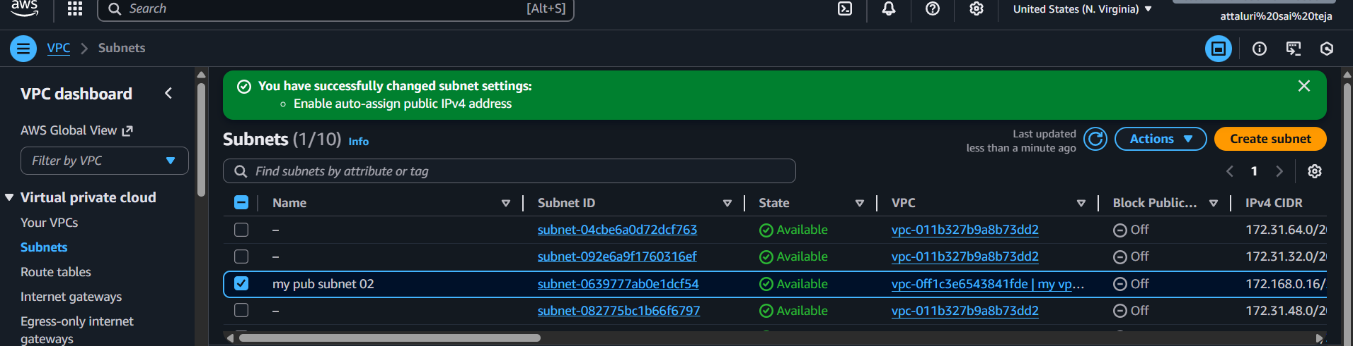
Do the same process for pub subnet 2
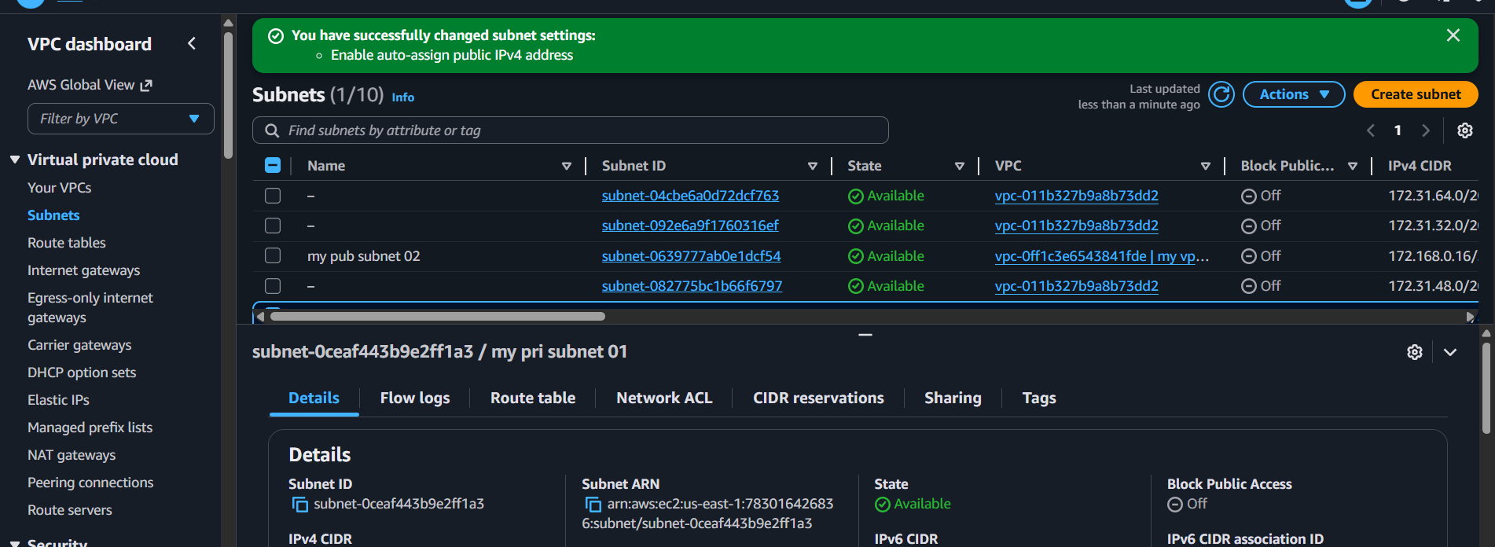

Add 2 private subnets in private route table.
Navigate to Route Table in Vpc Section
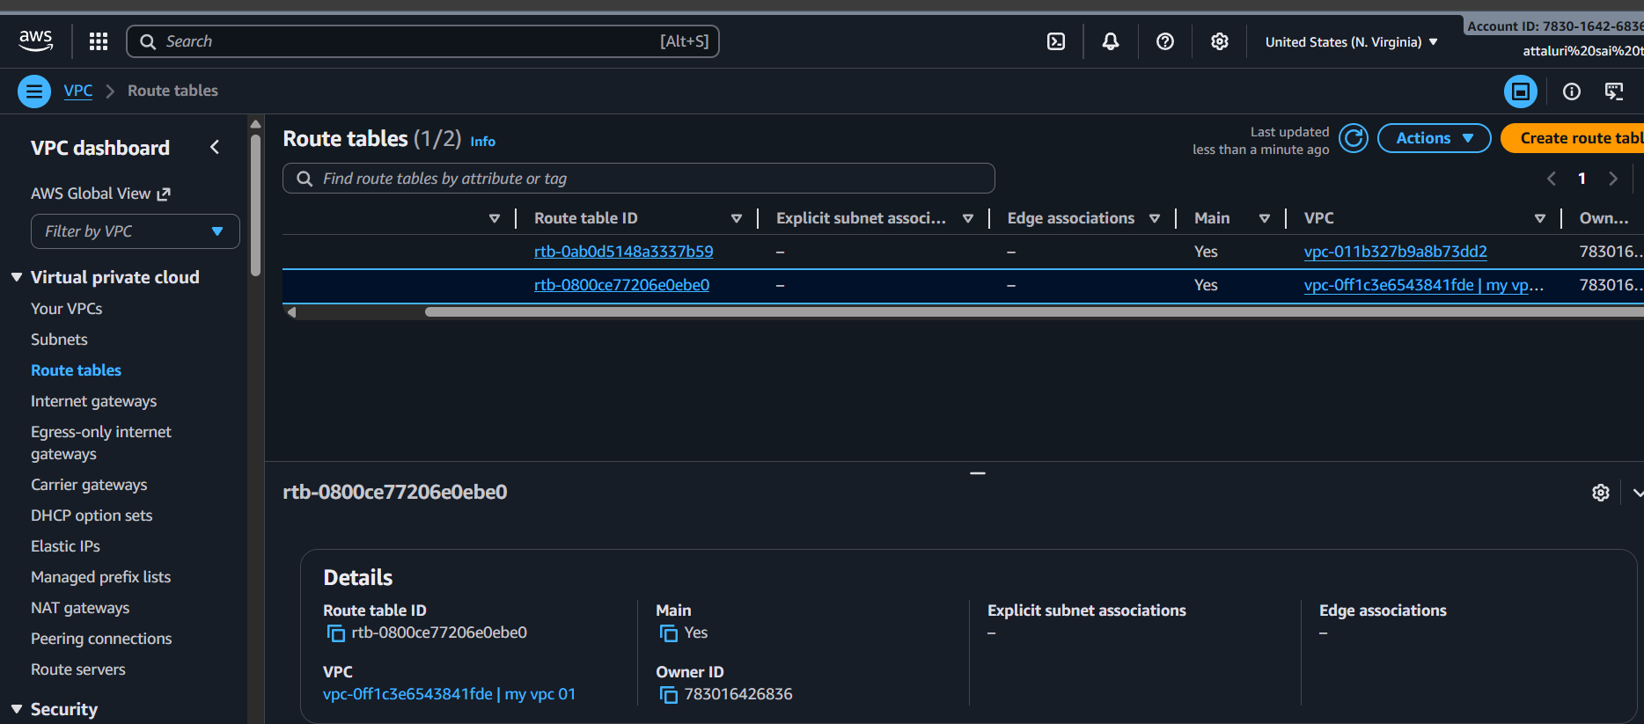
Select the option Create Route Table from right corner and add the name to RT
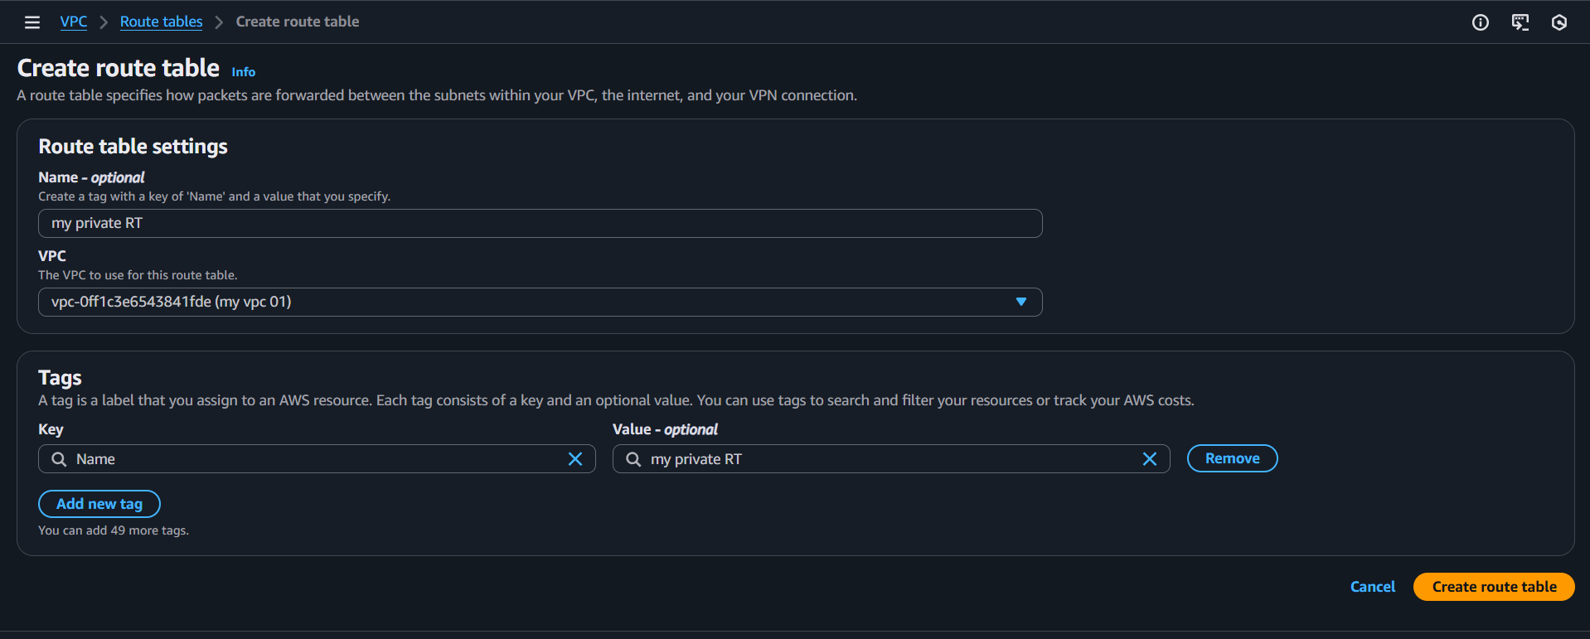
Then save to create a private RT
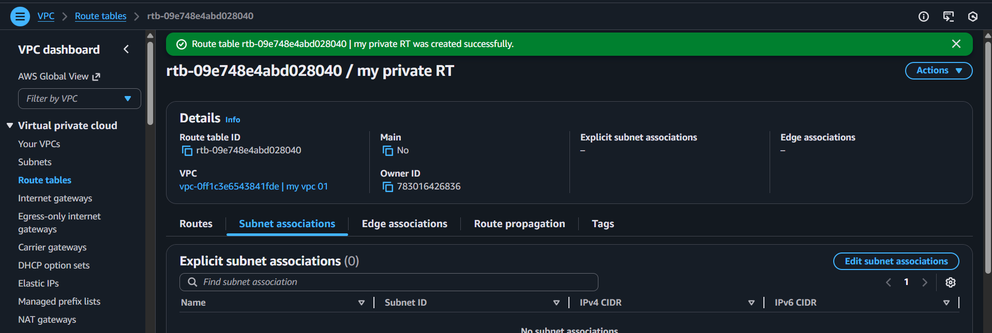

Then Navigate to subnet assocaiations in route and select private subnets and click on save association
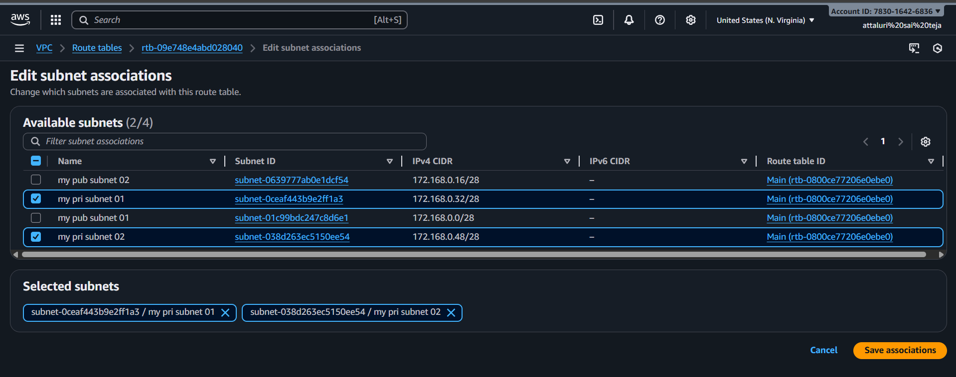
Then you ve added private subnets to RT
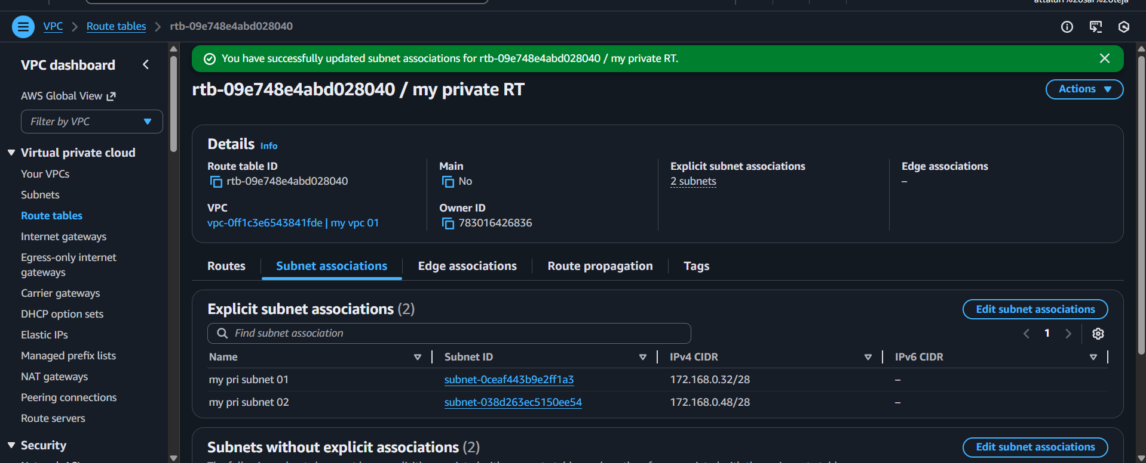

Add 2 public subnets in public route table.
Same process as private subnets done in above task
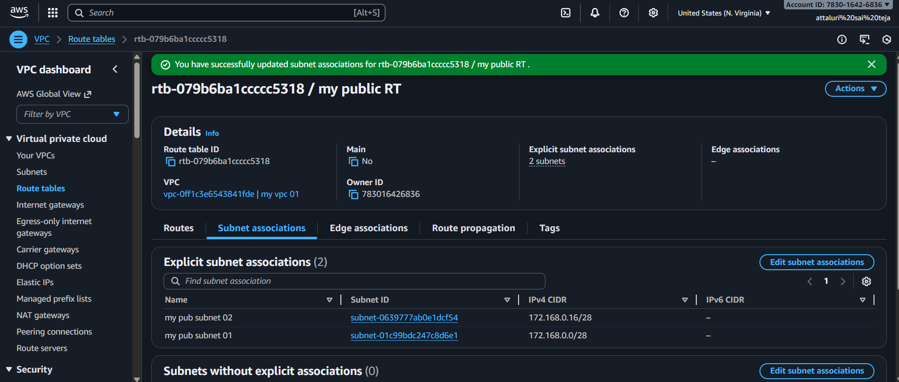
Verified in route table
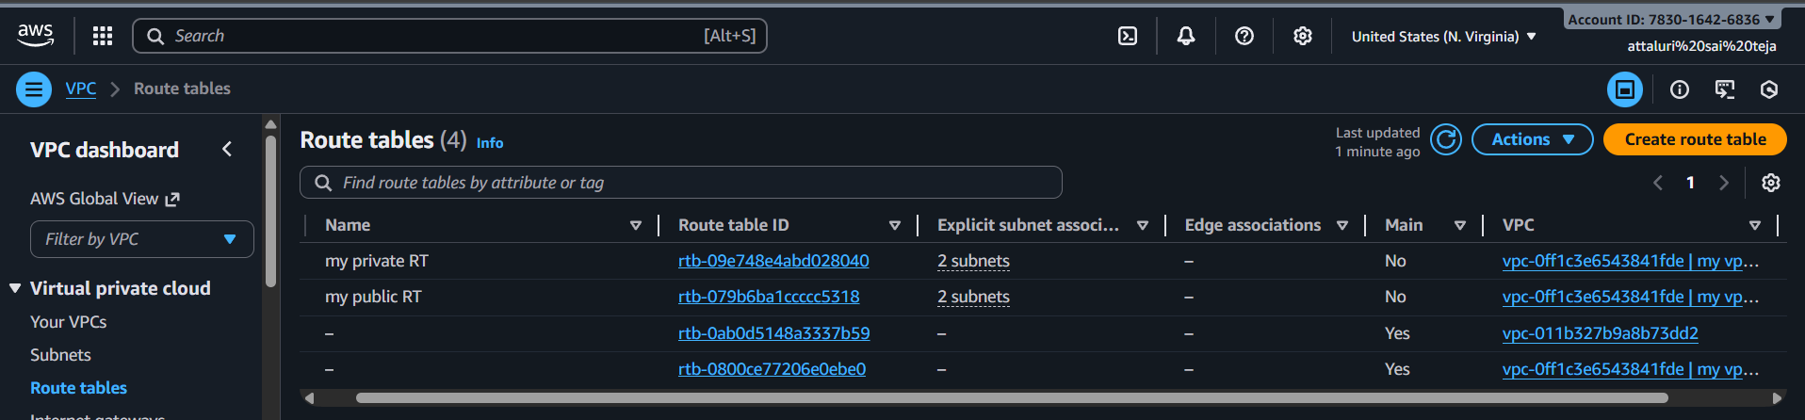

Public route table will have the routes to internet and local
Navigate to internet gateway section and create a internet gateway
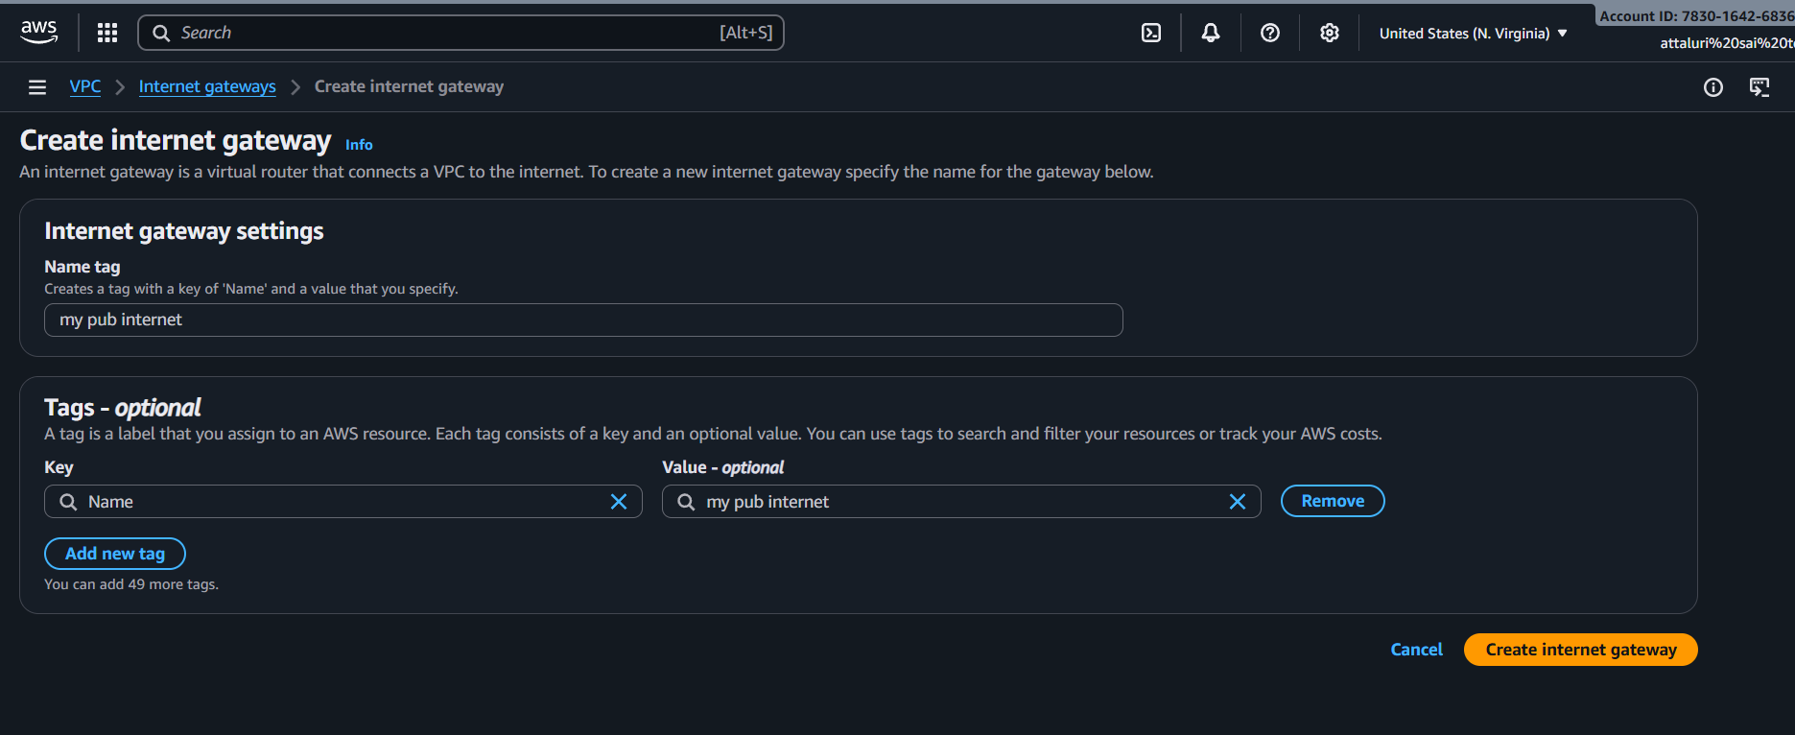
Then click on attach to VPc option
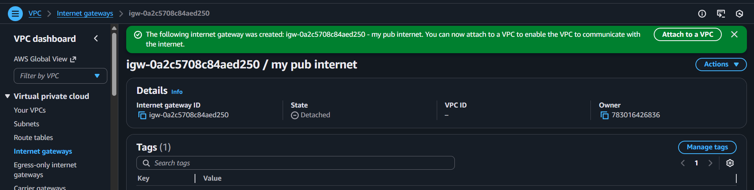
Then add your vpc and apply the changes
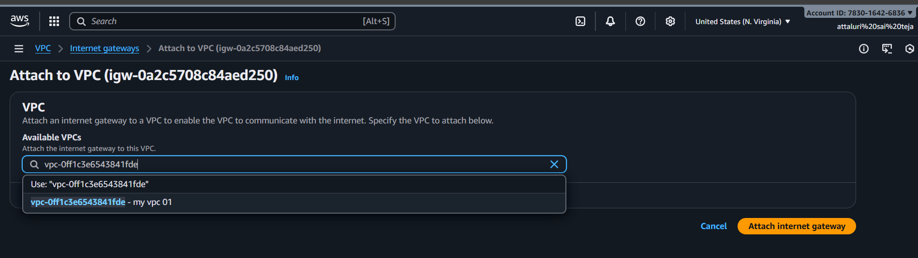
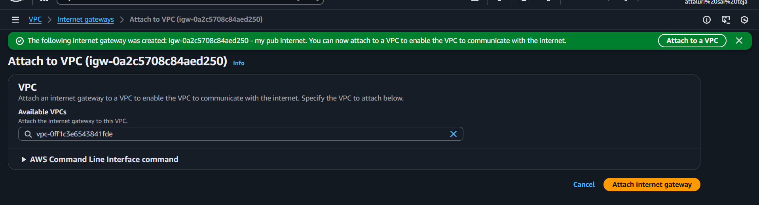

Here you can see the status as Attached
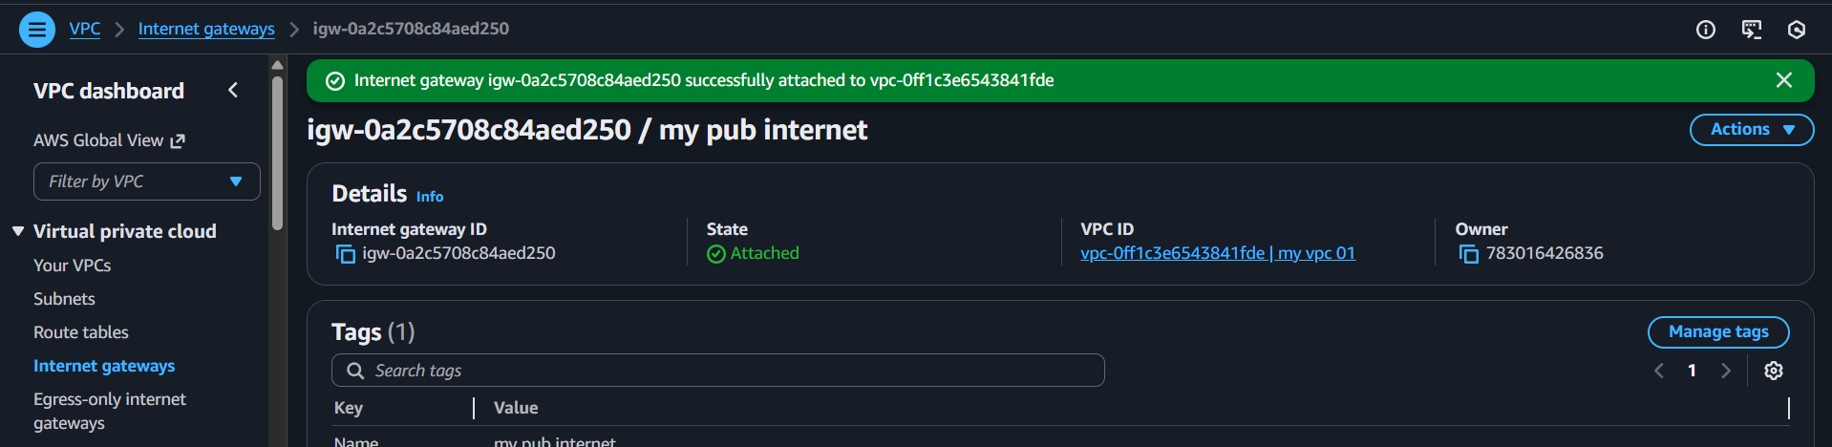
Navigate to route tables and add the route and select the options and click on save
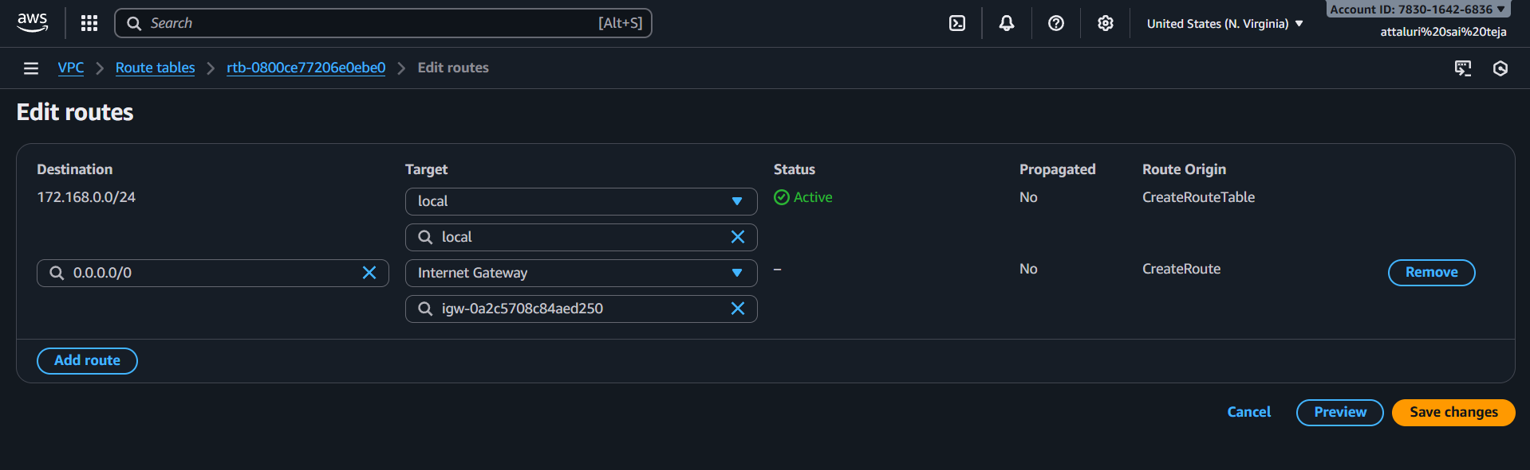
Your subnets are routes were updated successfully
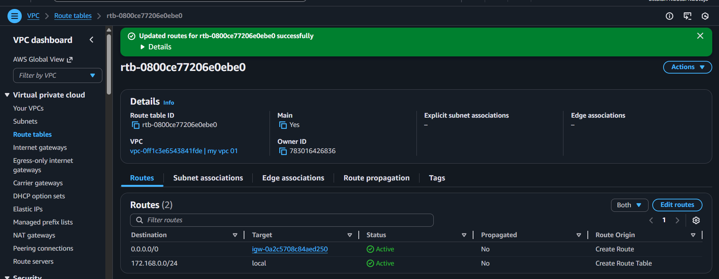
The navigate to route tables and add pub subnet routes to provide internet access and save the changes
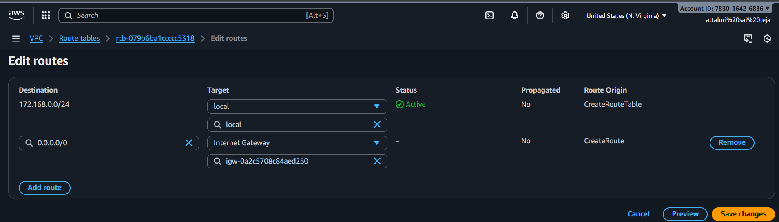

Then your public subnets are connected to internet
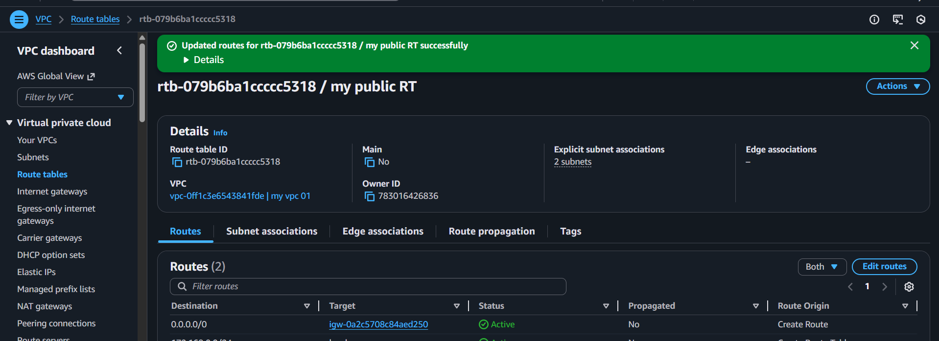

Create EC2 in public subnet with t2.micro and install PHP.
Launch the instance in regular way but need to change some changes
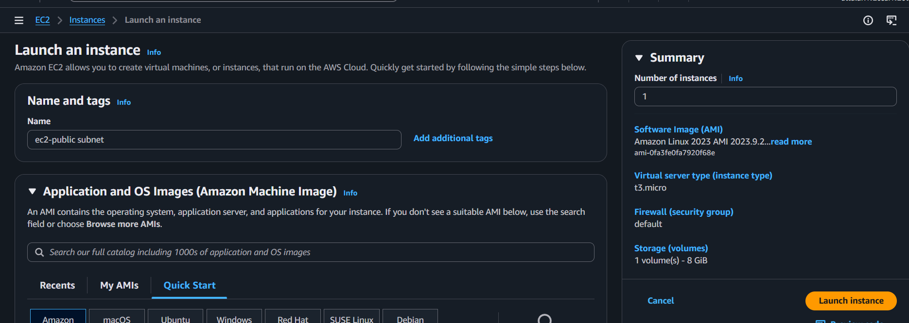
Changes to be modified in network settings
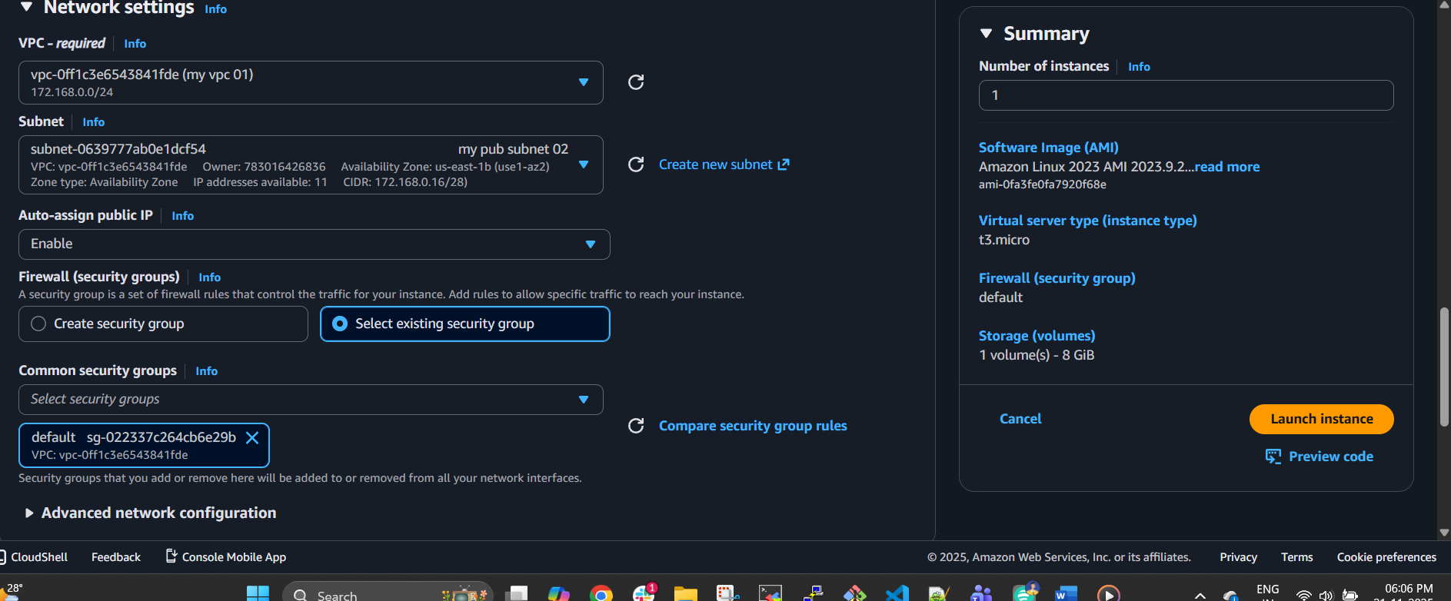
Instance has been launched
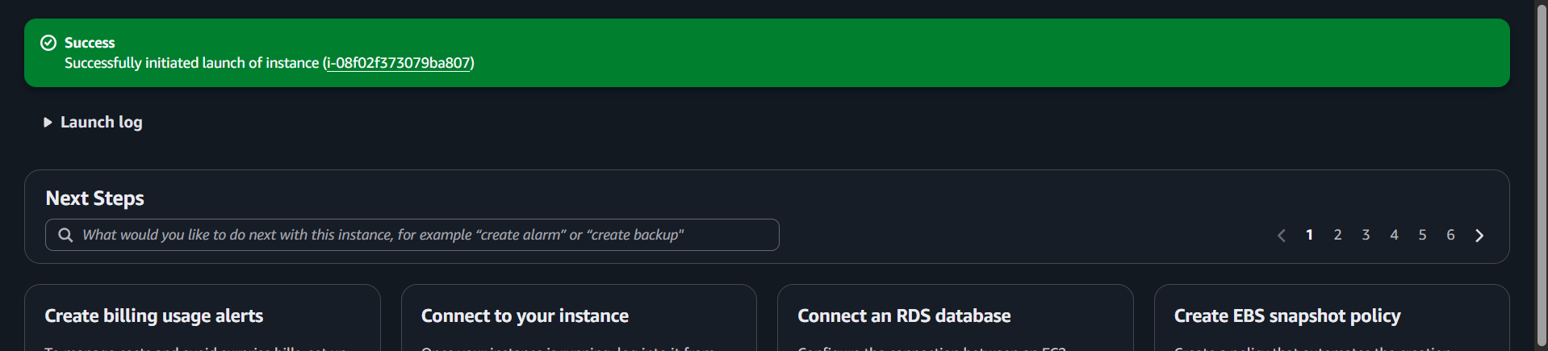

Verified in instances page/section
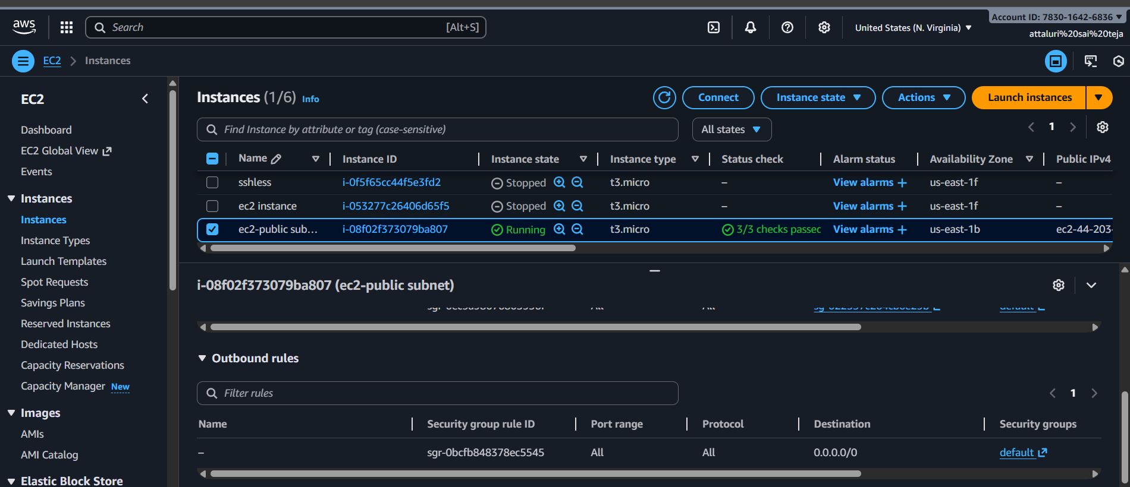
Verified the ip address which we give in public subnet
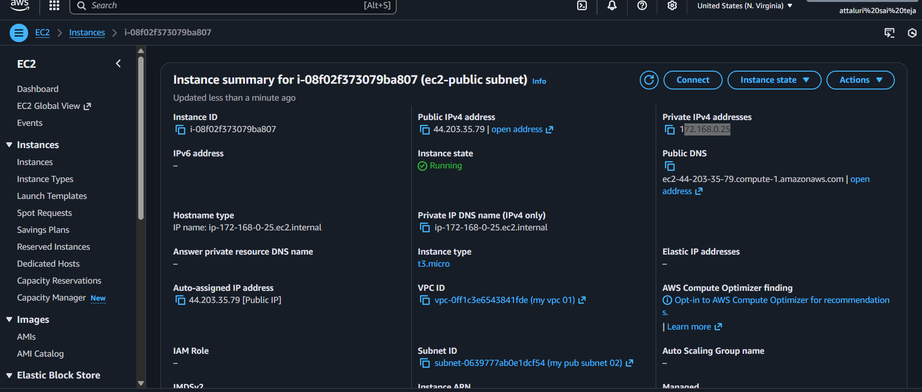
Edited inbound rules to access with ssh
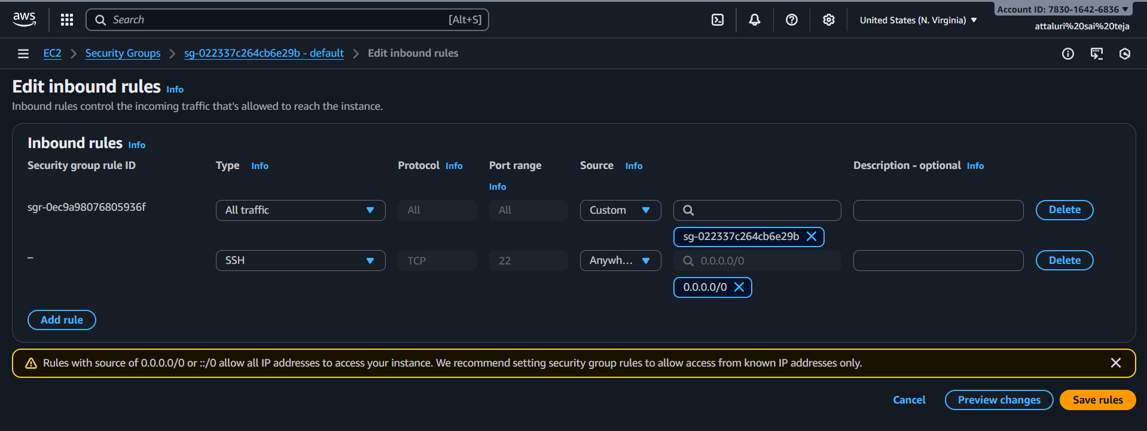

Then got a pop up of updated security groups
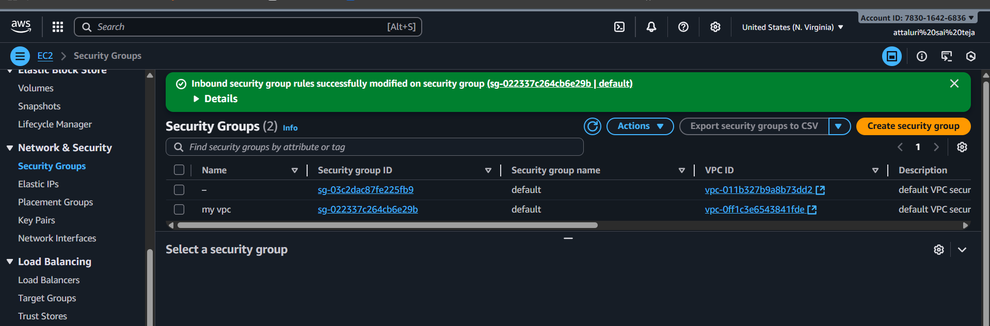
Before changing the security I unable to connect with ssh after changing SG im able to connect
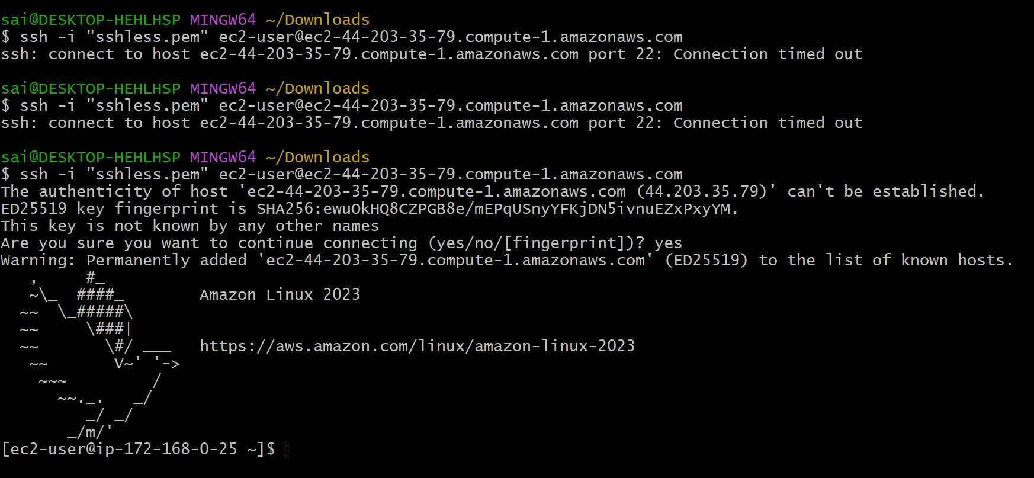
Used command yum update -y to update the dependencies
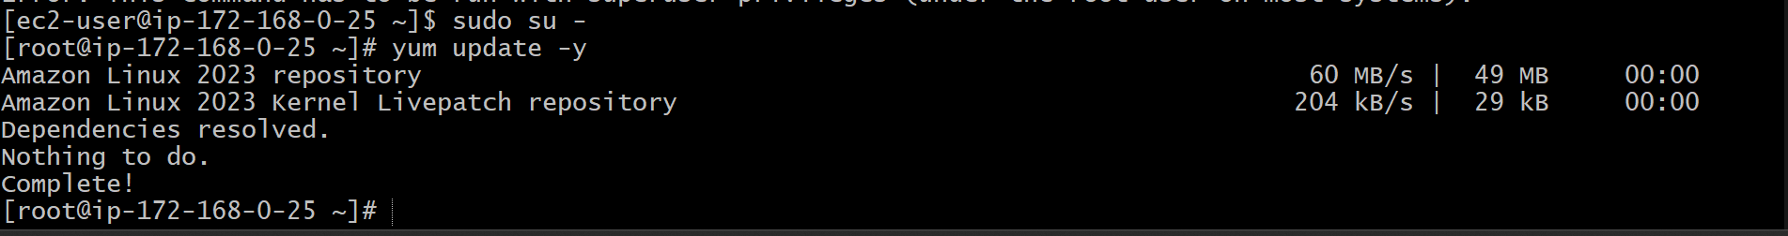
Installed PHP using command yum install php -y
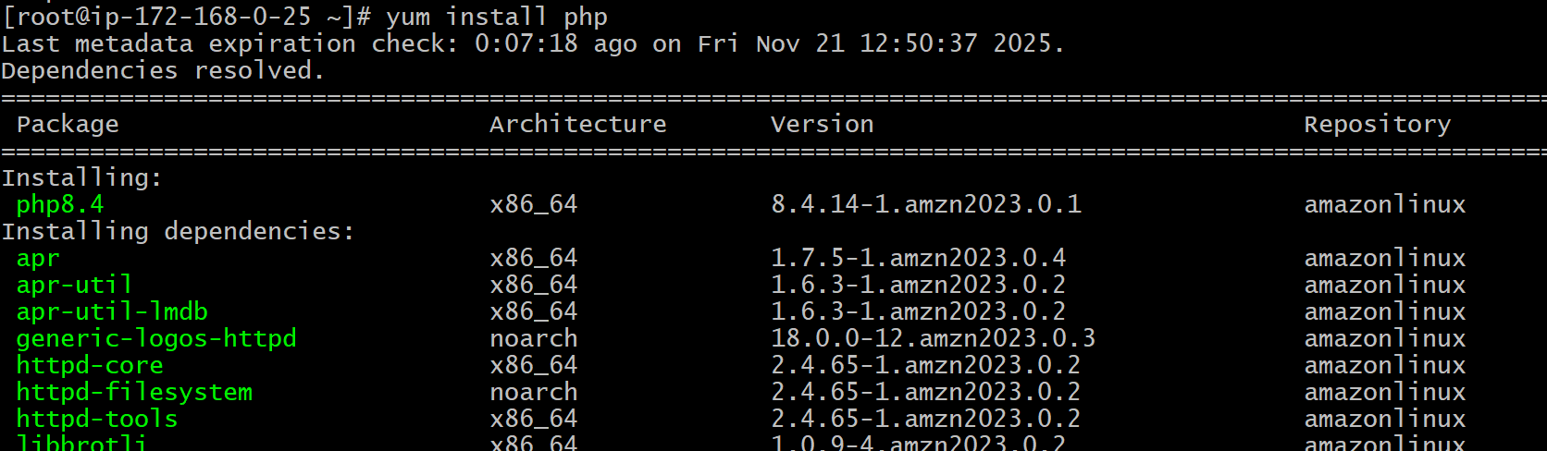
Verified the installation
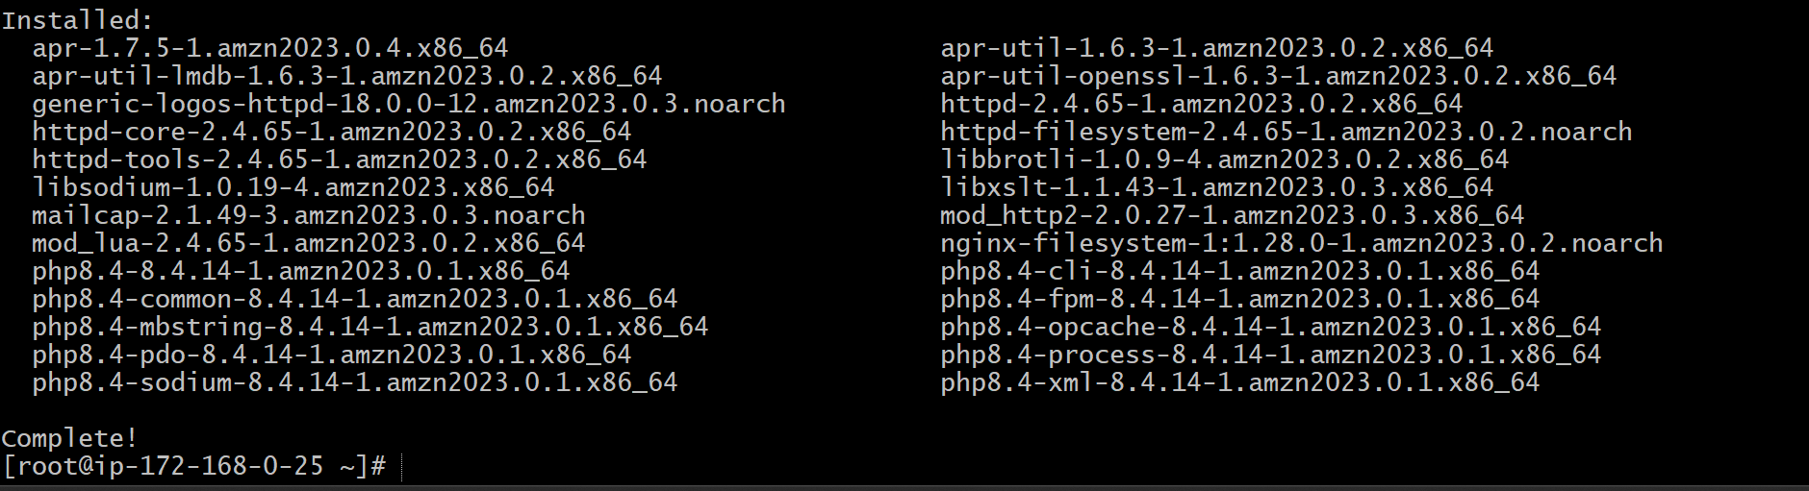
The Full form of PHP is Hypertext Preprocessor and earlier it was abbreviated as Personal Home Page. It is a general-purpose programming language used to design a website or web application. It is the server-side scripting language embedded with HTML to develop Static website, Dynamic website, or Web applications.
Using command
sudo echo "<?php phpinfo(); ?>" | sudo tee /var/www/html/phpinfo.php > /dev/null
to verify the installation
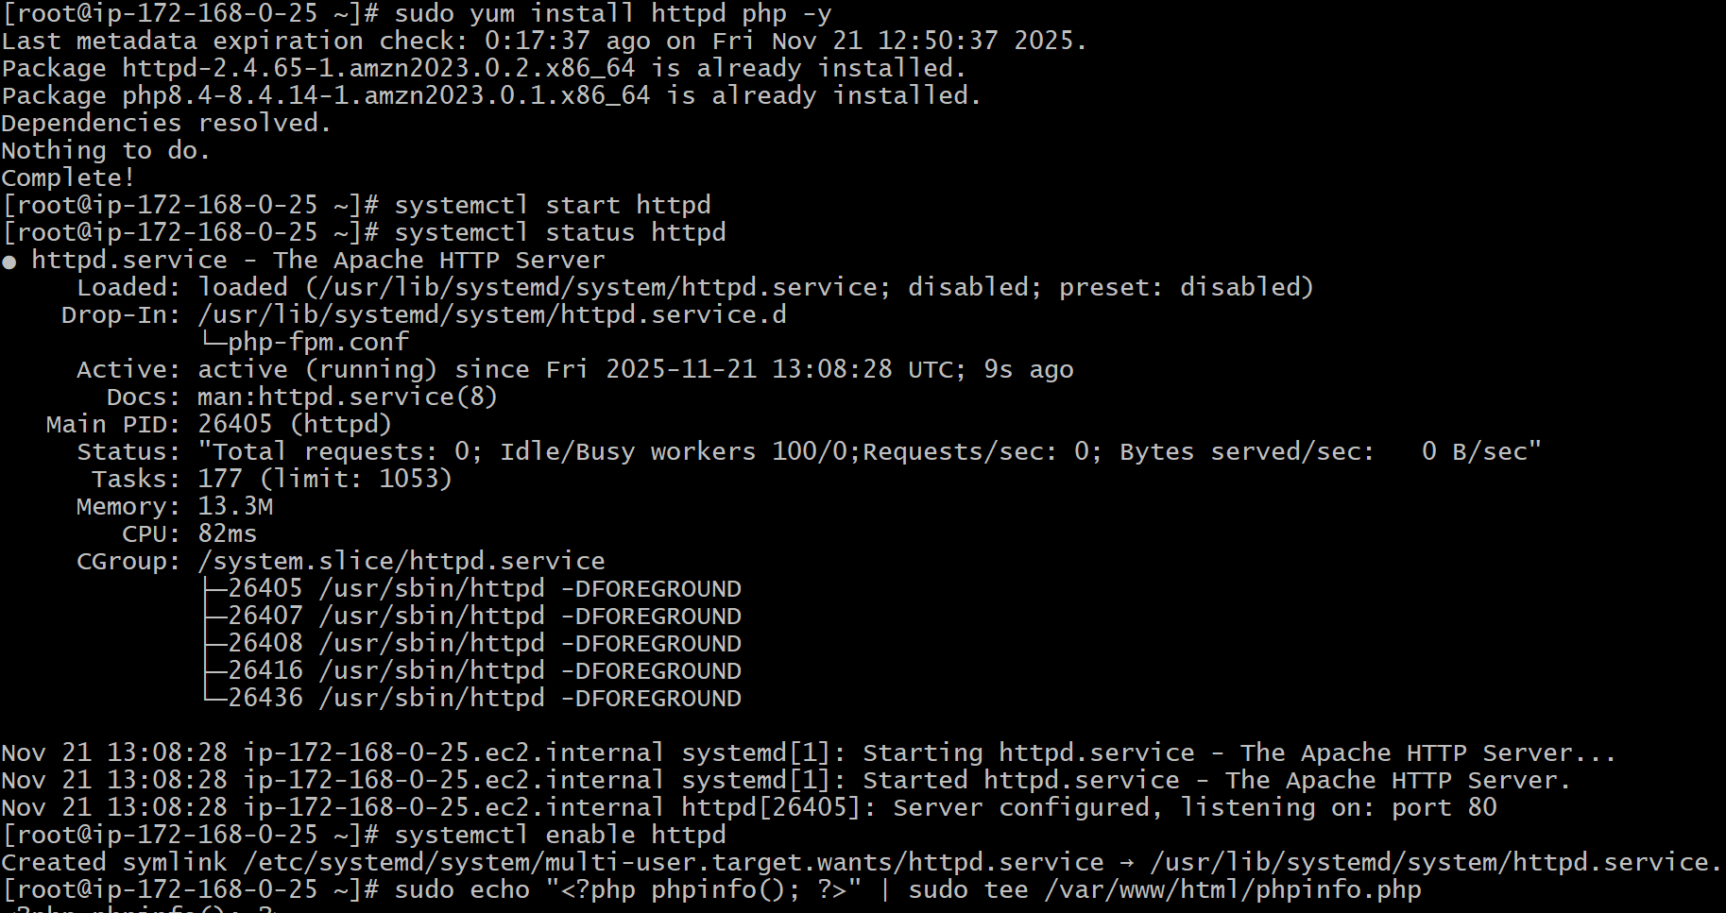

public ip @phpinfo.php both httpd and php will work and don’t forget to enable security groups for hhtpd
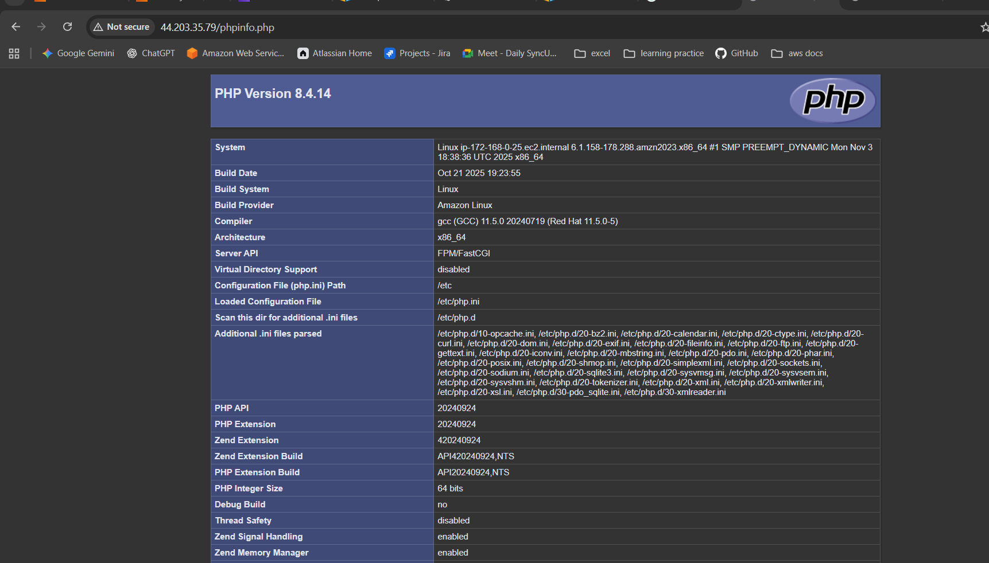

Configure NAT gateway in public subnet and connect to private instance.
Step 1: create a vpc of your own
Step 2: create 1 private subnet
Step 3: create 1 public subnet
Step 4: create 2 routes using route table
Step 5: create 1 internet gateways and attach vpc into it
Step 6: attach the internet gateway in public subnet in route table
Step 7: attach subnet of public into public RT in subnet association section
Step 8: create NAT gateway and select public connectivity and Generate elastic ip while authorising NAT gateway attach public subnet into it
Step 9: Change the routes in route table accordingly
Step 10: apply IGW for Public Route table routes (for public subnet)
Step 11: Apply NAT gateway for private route or private subnet
Step 12: Attach public subnet into NAT gateway
Step 13: Launch 1 instance from public server and enable ipv4
Step 14: launch 1 instance from private server and disable ipv4
Step 15: change the security groups of both
Step 16: in your git bash or any CLI cat the pem key and copy it
Step 17: Connect to instance using git bash / any CLI
Step 18: verify the internet connection by updating or running ping Commands
Step 19: if permission denies use SUDO
Step 20: create a .pem file extention using touch or vi and insert the pem key data into it you ve earlier copied
Step 21: Change the permission of the file to read only access Chmod 400
Step 22: Connect to your Private instance from your public instance without logging off or exiting it directly run the command
Step 23: Verify the internet access by updating or installing services
Step 24: you’ve successfully connected to internet using NAT Gateway

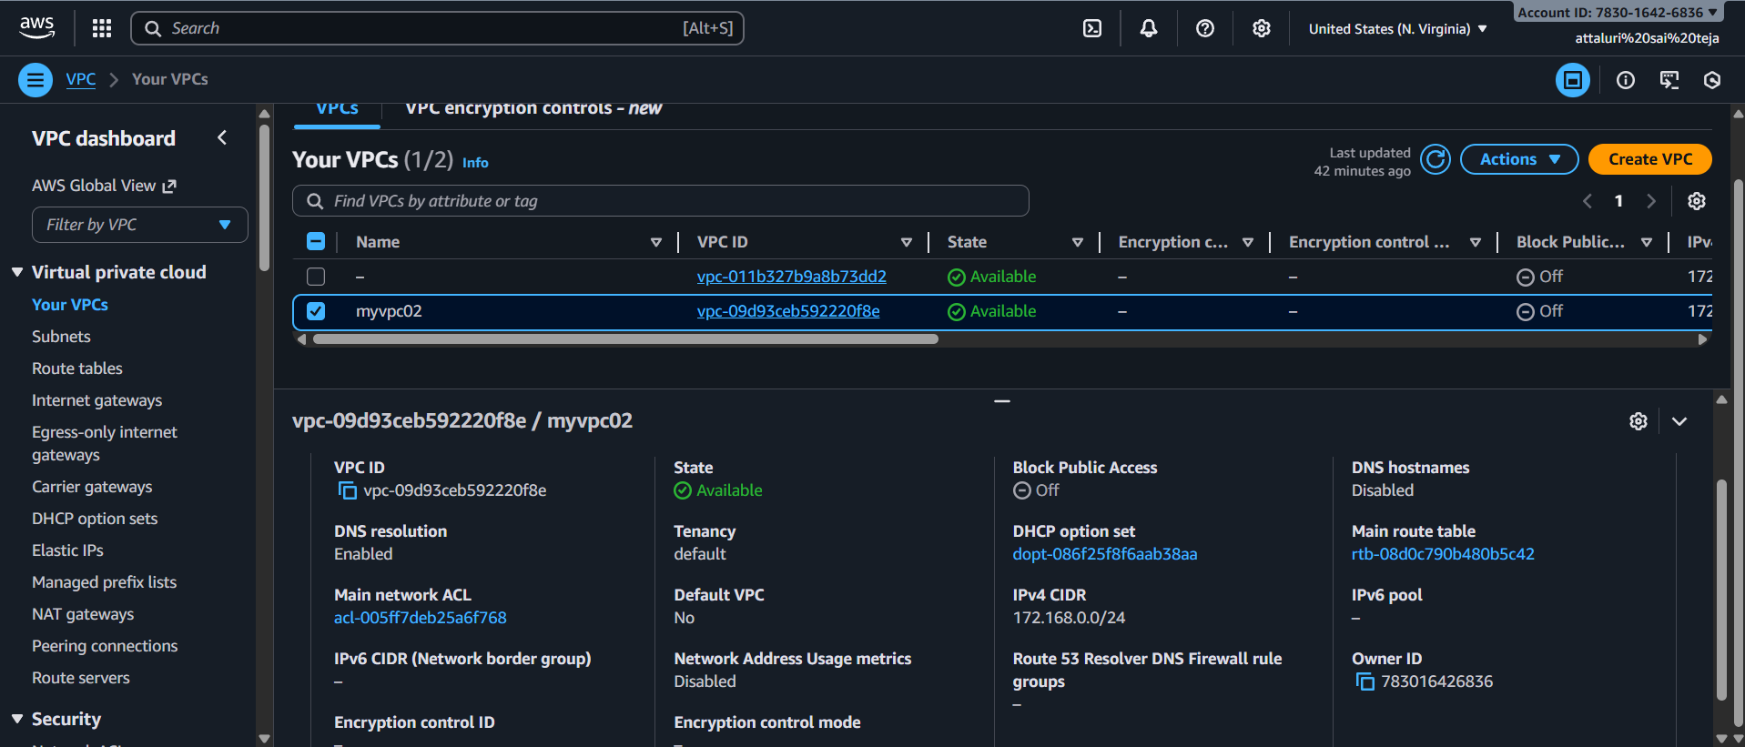
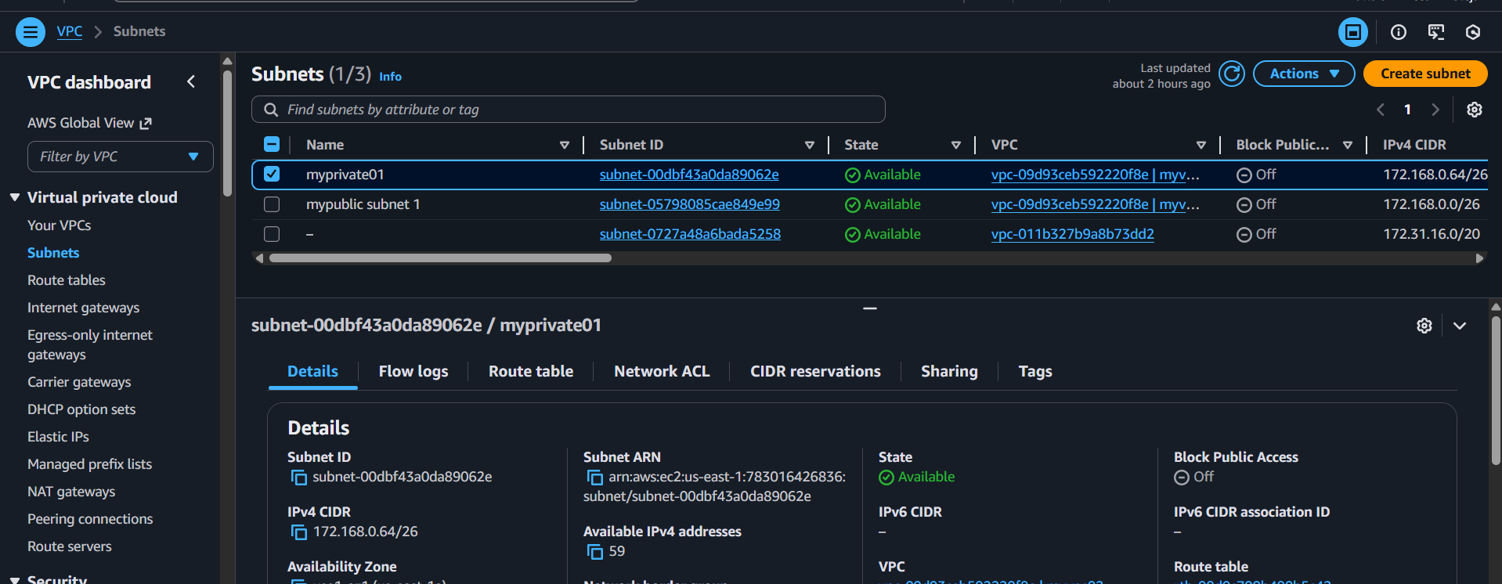
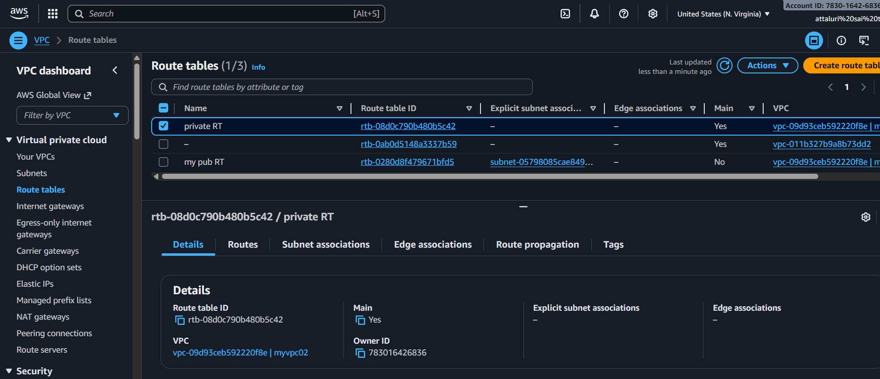
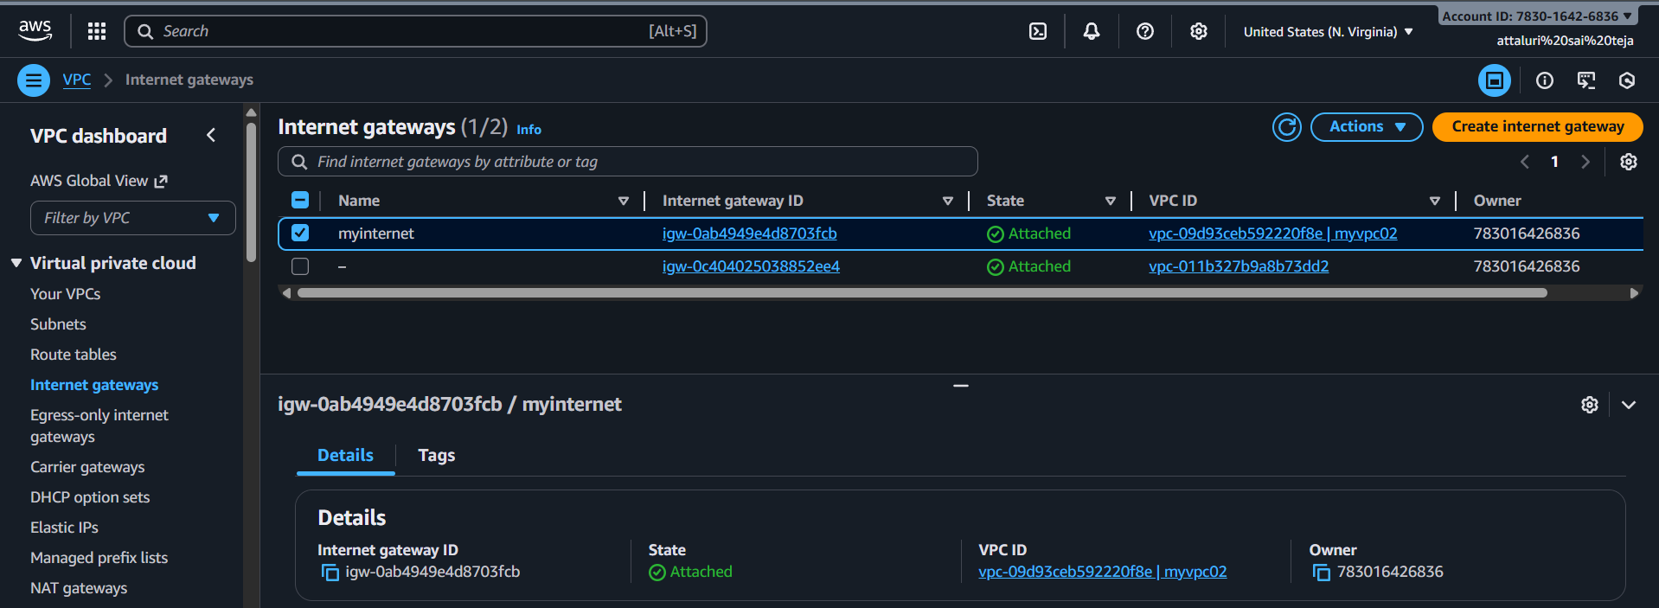
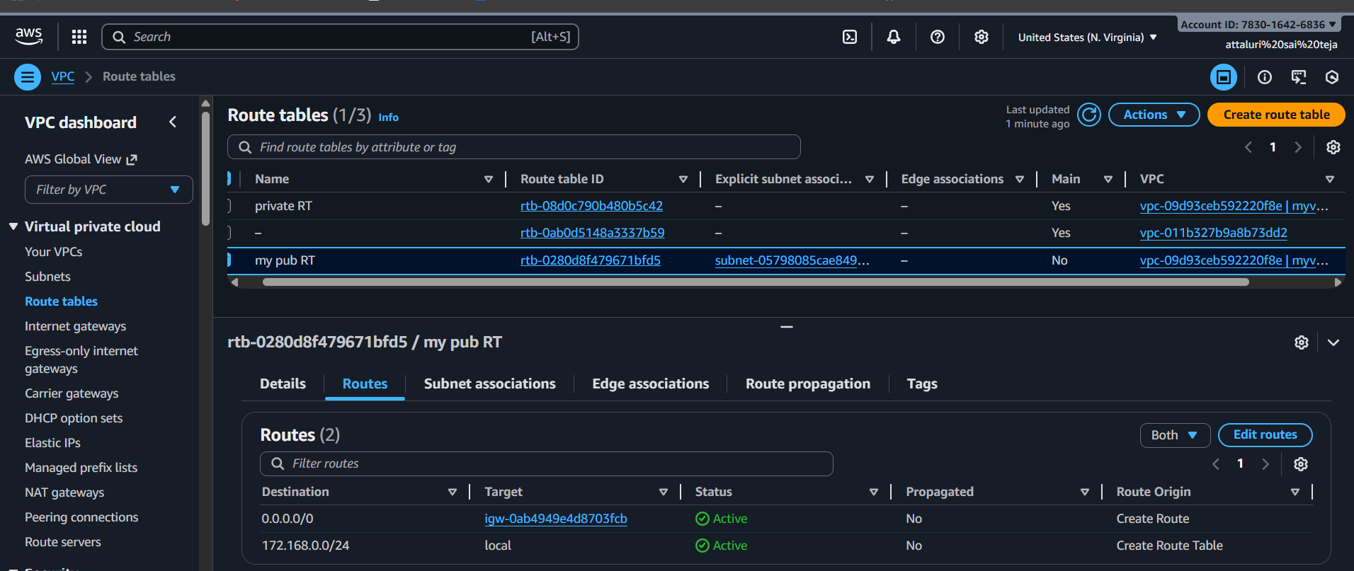
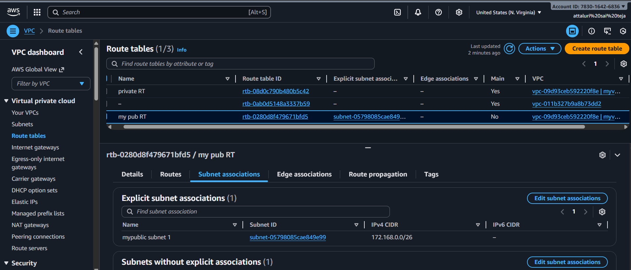
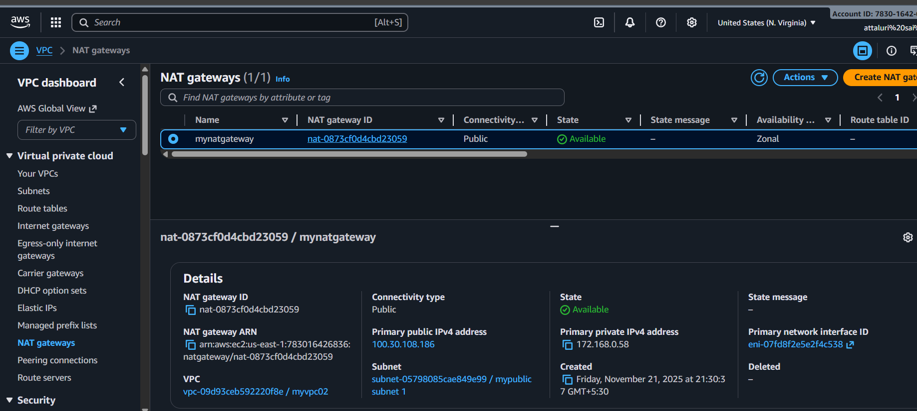
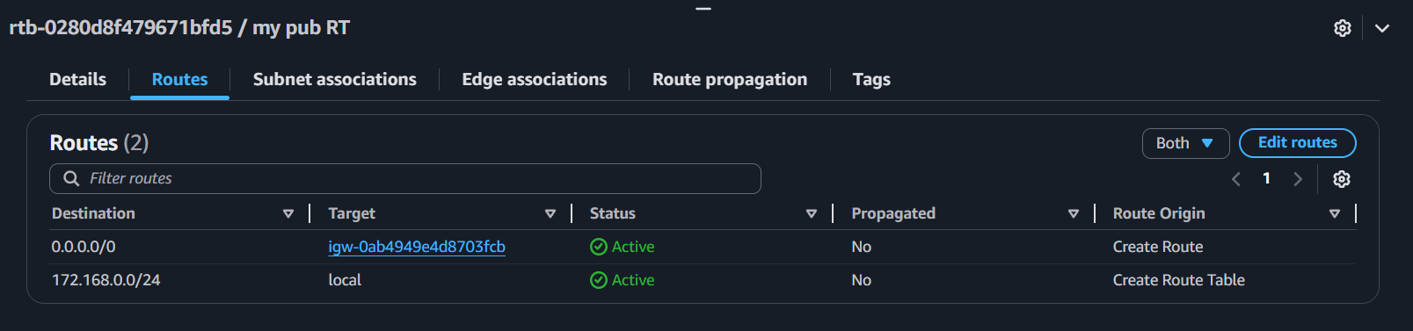
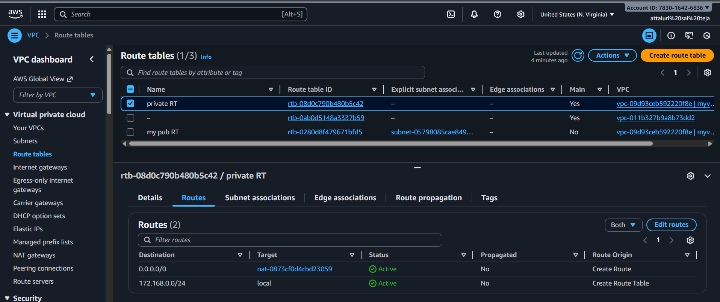
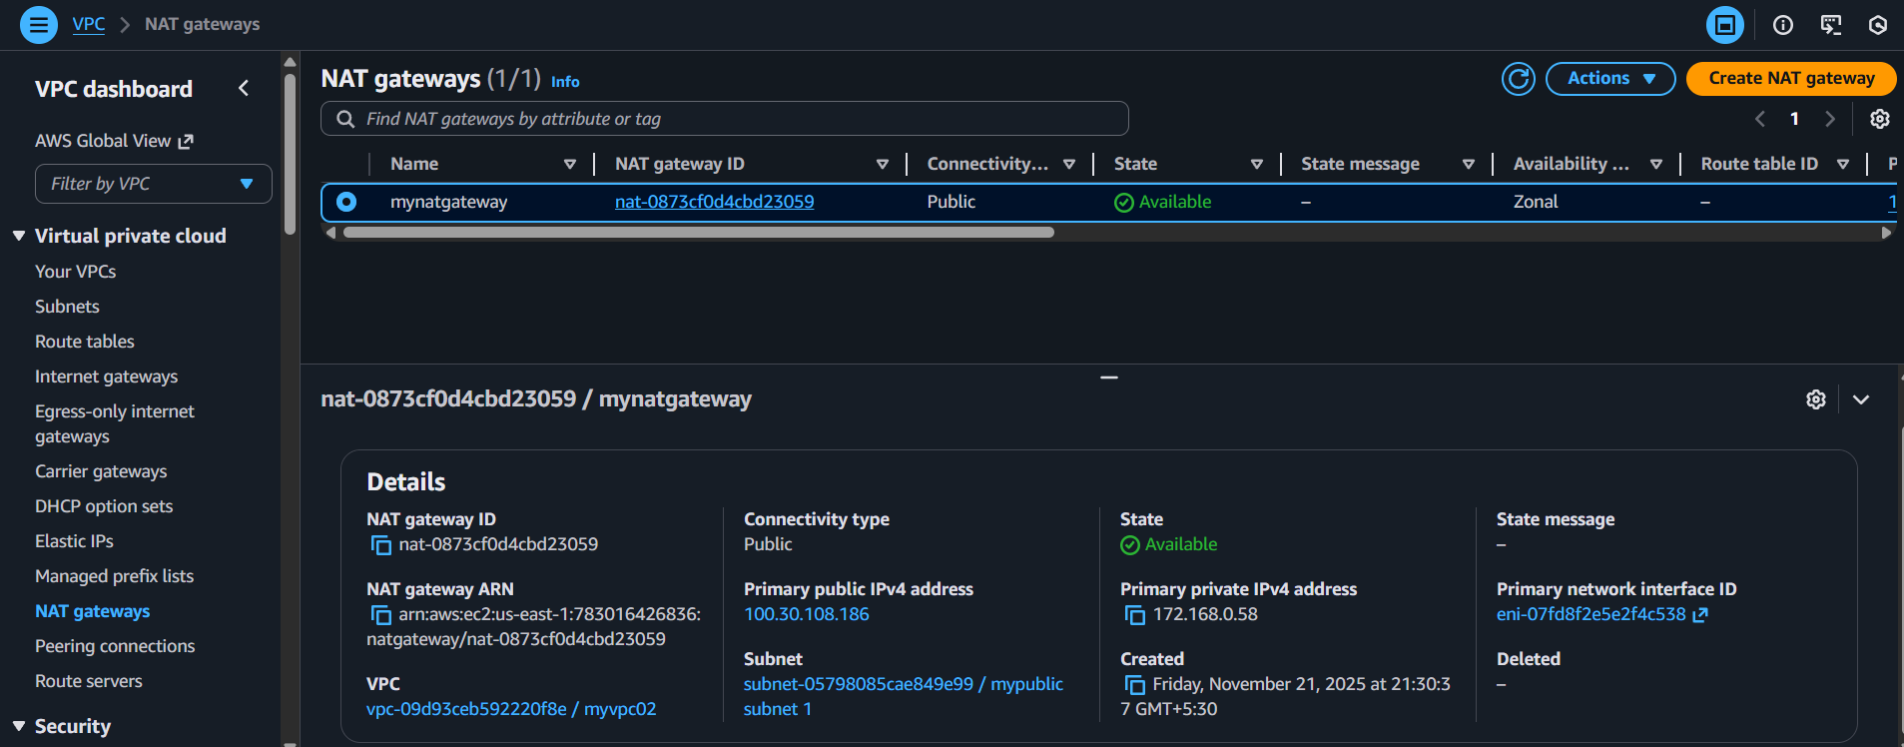
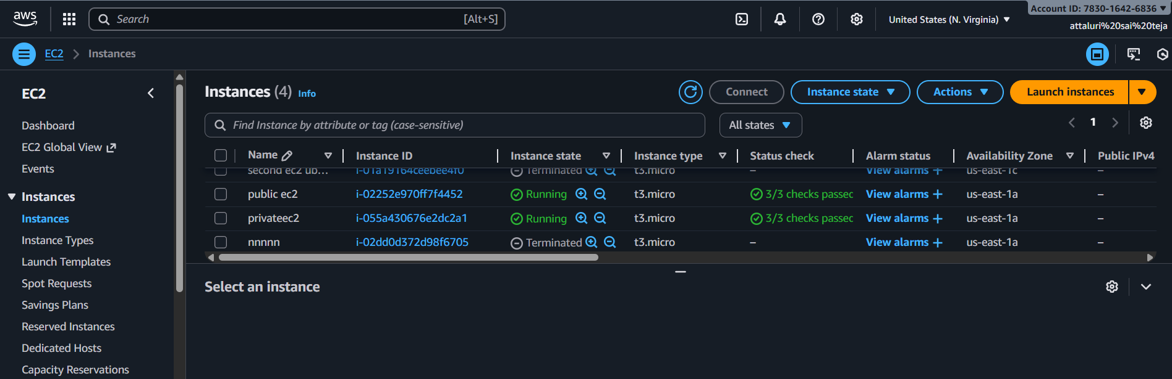
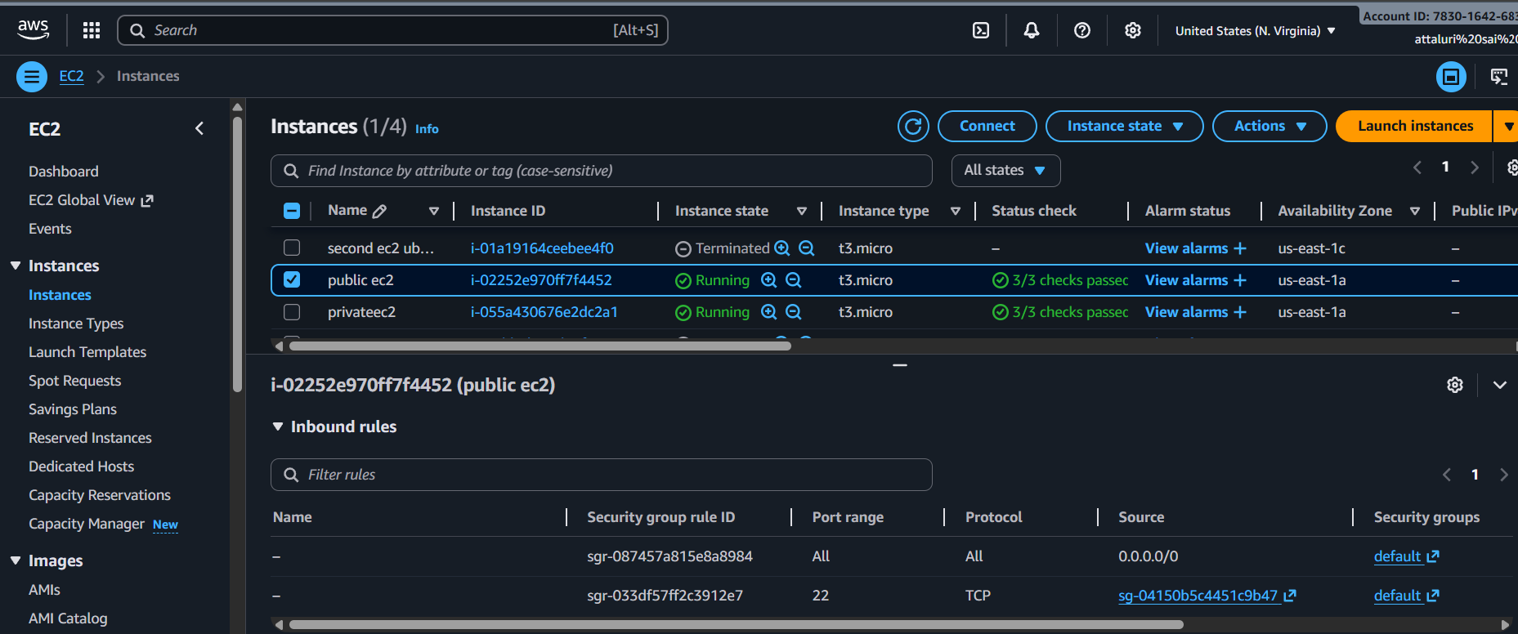
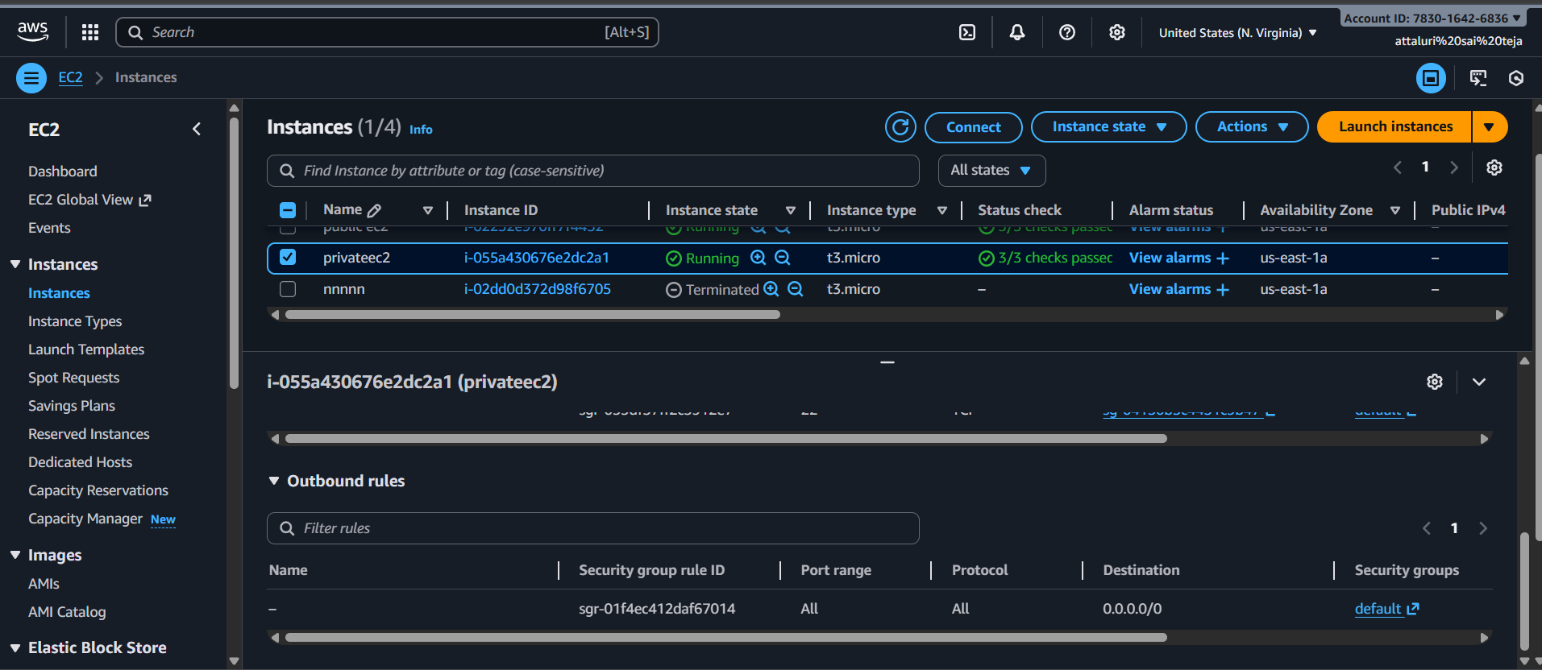
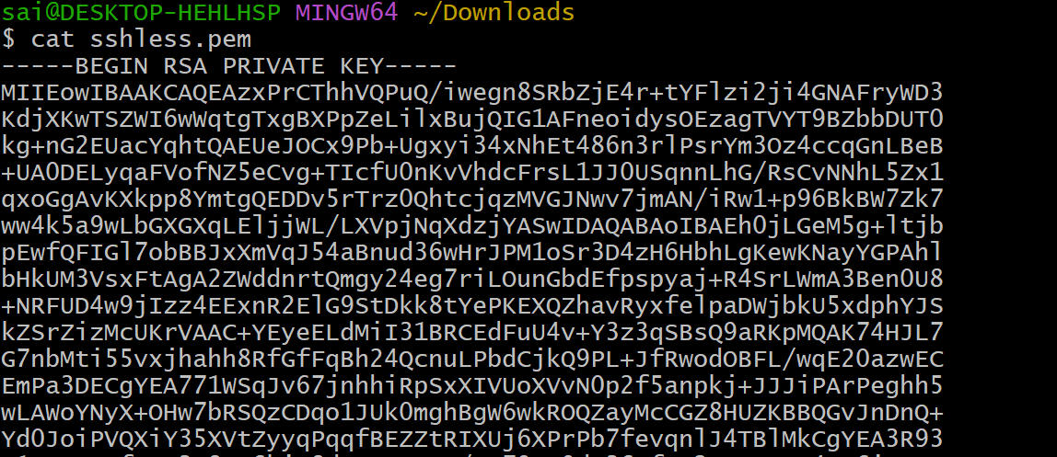
Logged in as public server
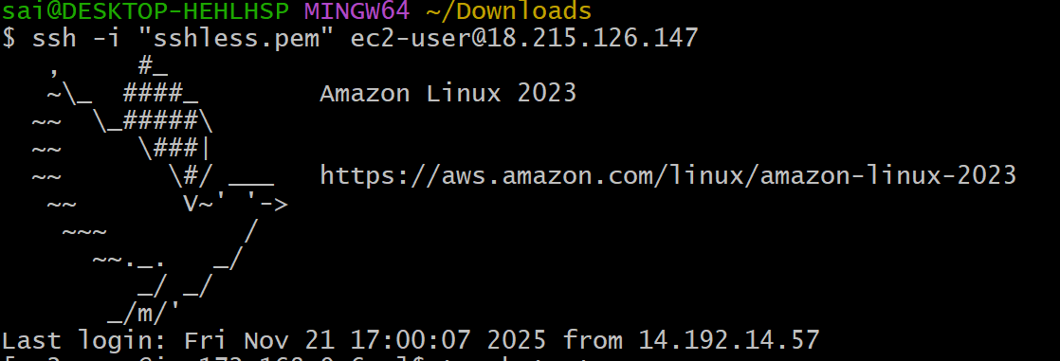

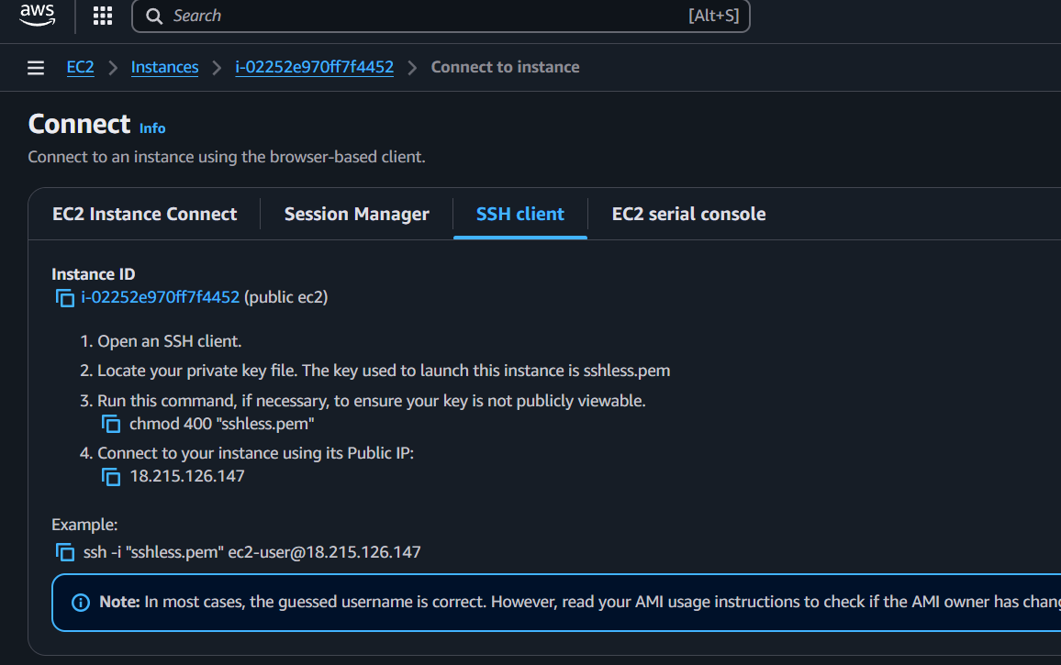
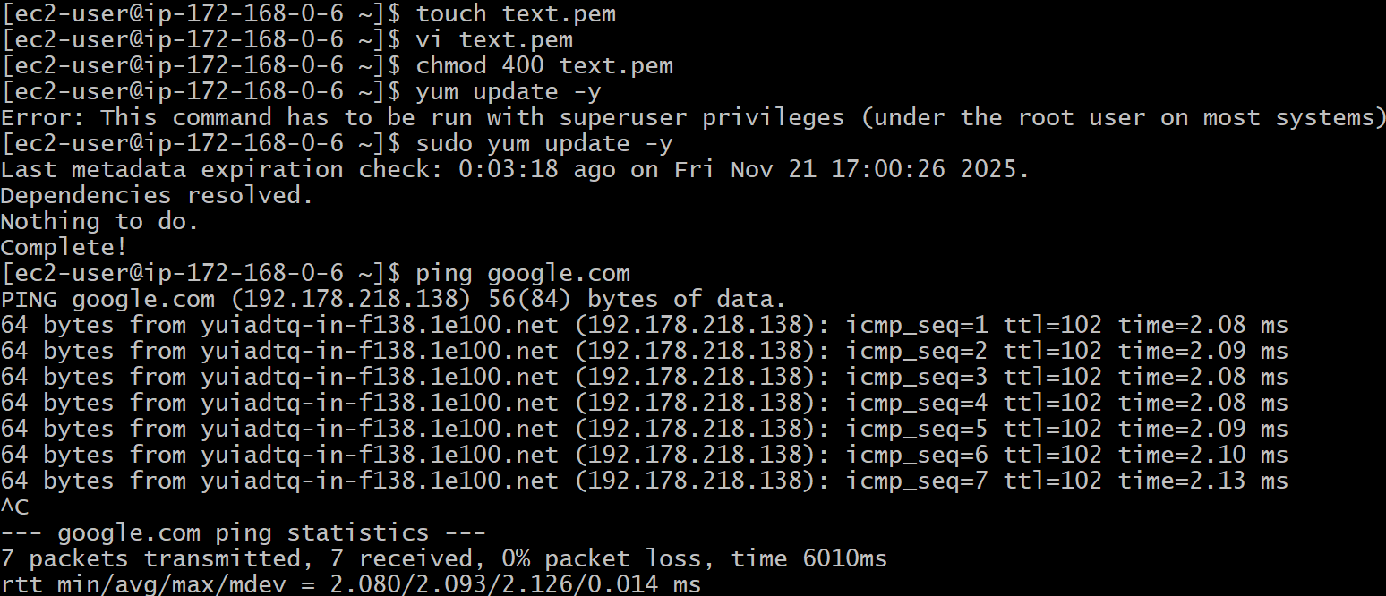

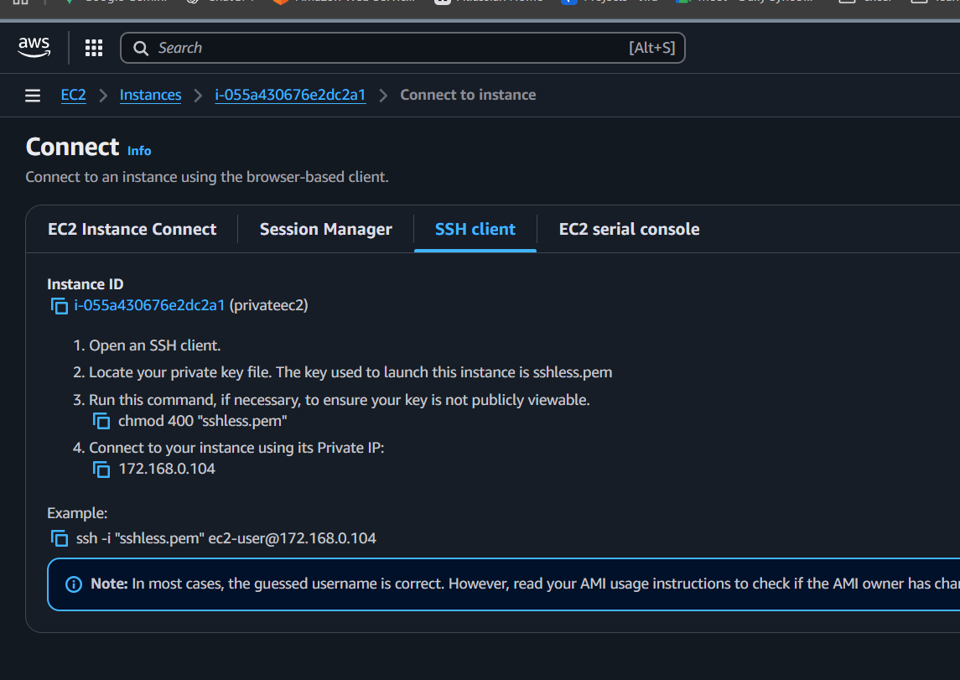
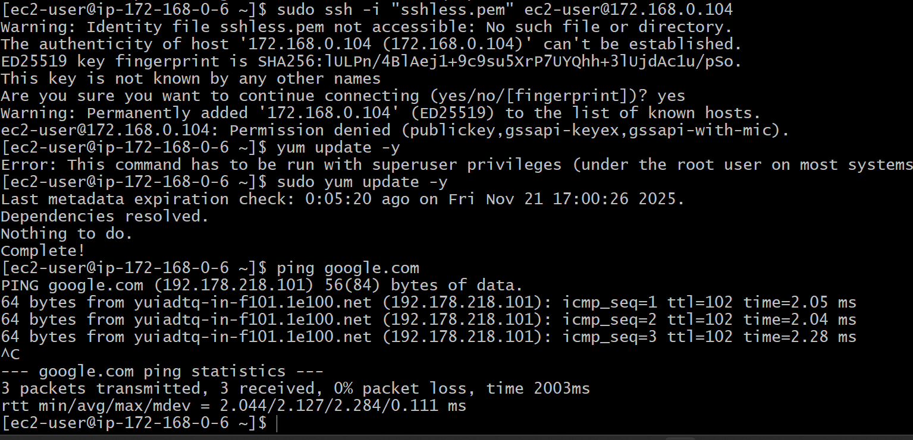
Look the above 2 pictures the ip address are different.
One is from public and one is private
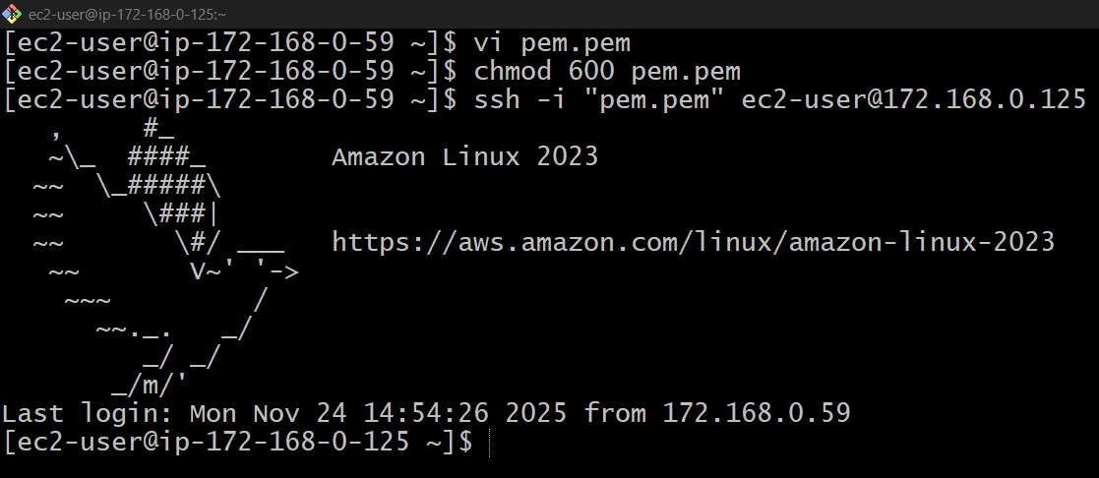

Install Apache Tomcat in private EC2 and deploy a sample app.
Install java sudo yum install java
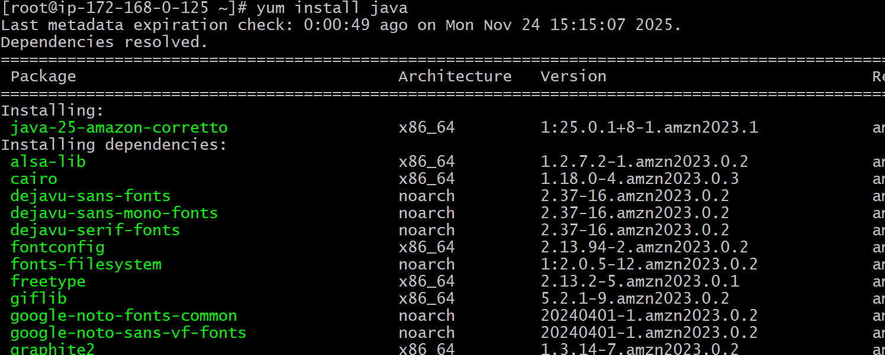
Change directory to opt cd /opt/
Wget link
Use command tar xvf command to xtract
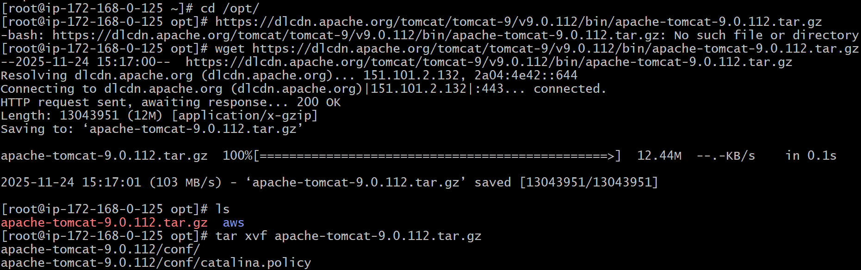
Change directory to apache
And change to bin
Start ./startup.sh
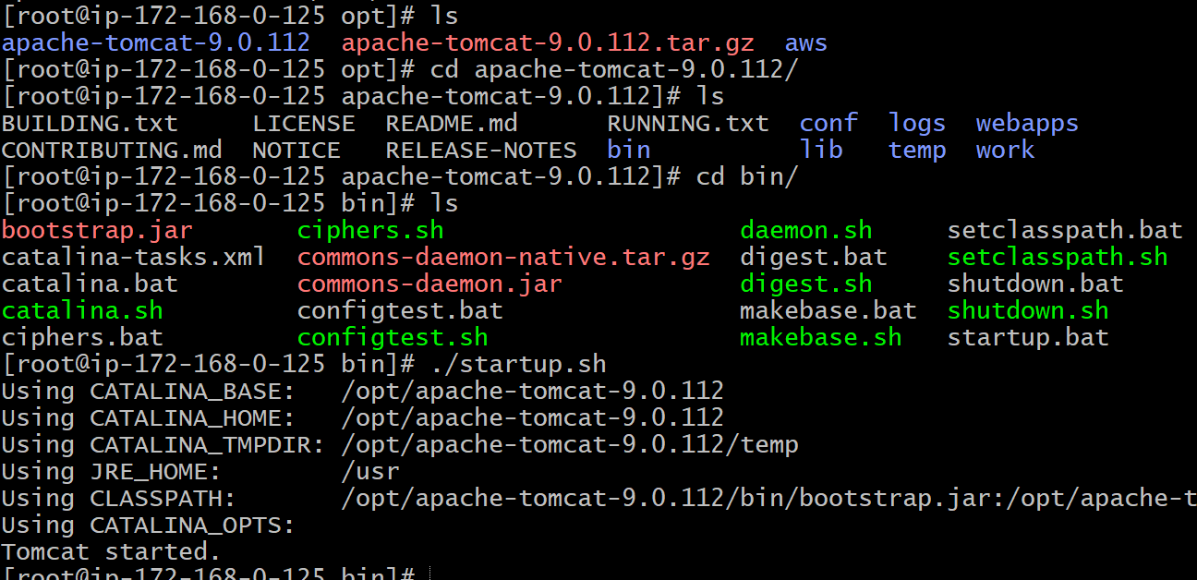
Verified sample app using curl http://privateip:8080

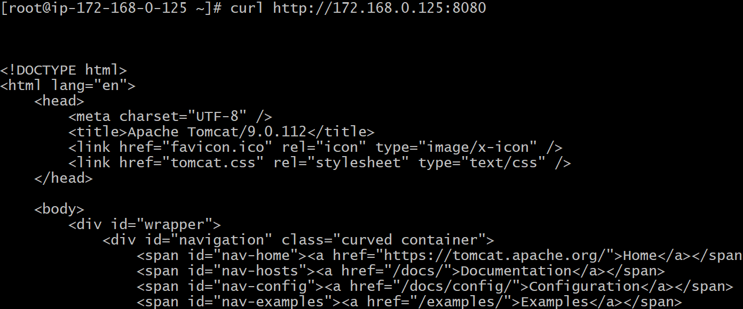

Configure VPC flow logs and store the logs in S3 and CloudWatch.
Navigate to your vpc and select flow logs section and create
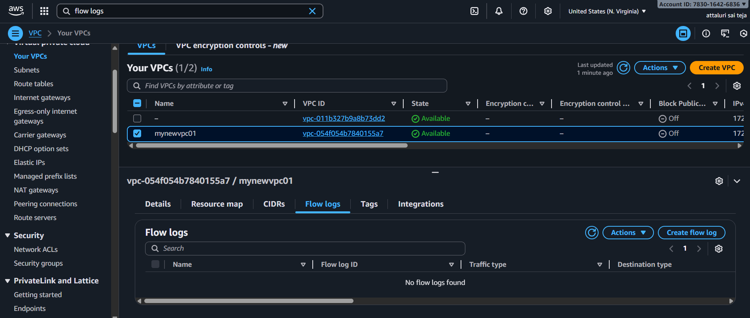
Going to create amazon s3 bucket
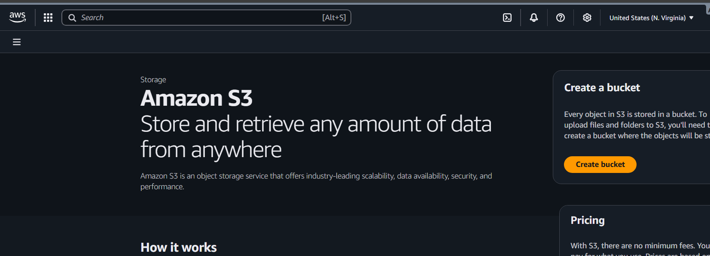
Enter the details with uniquename
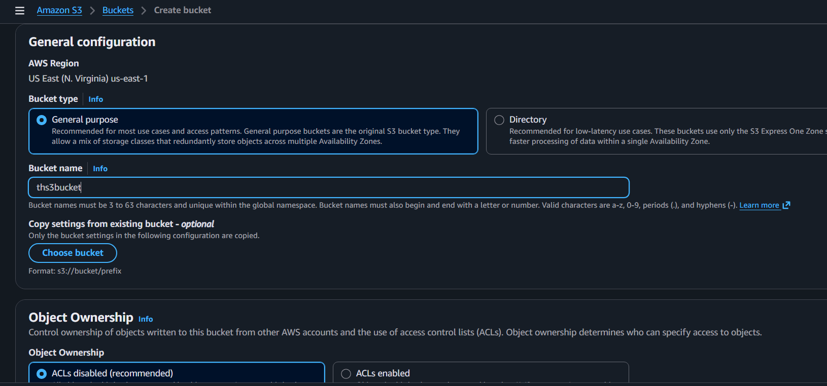
Deselect the option of block all public access
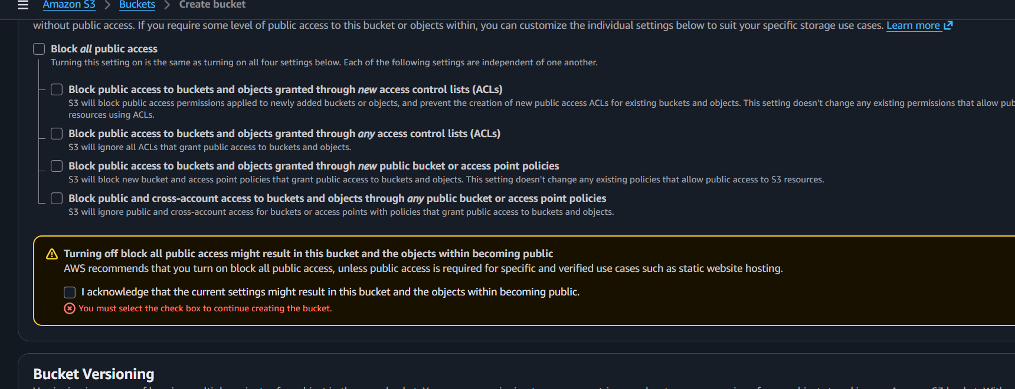
Then save to create
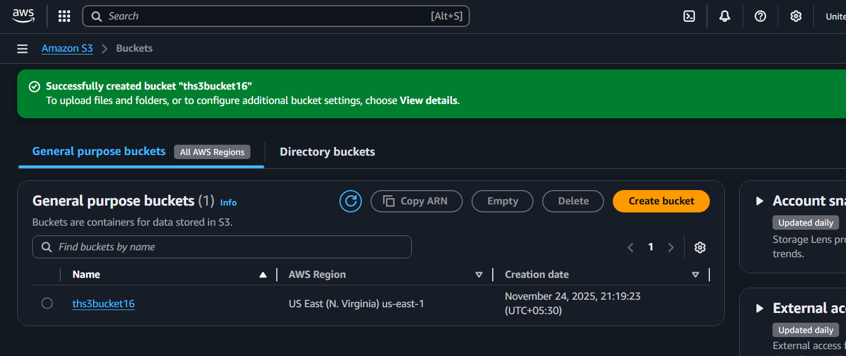

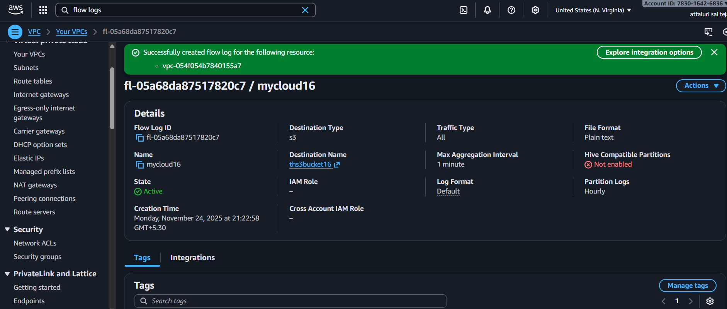

Navigate to amazon s3>buckets>awslogs>7830>vpcflowlogs>us-east>2025>11>24> 15 to list the logs
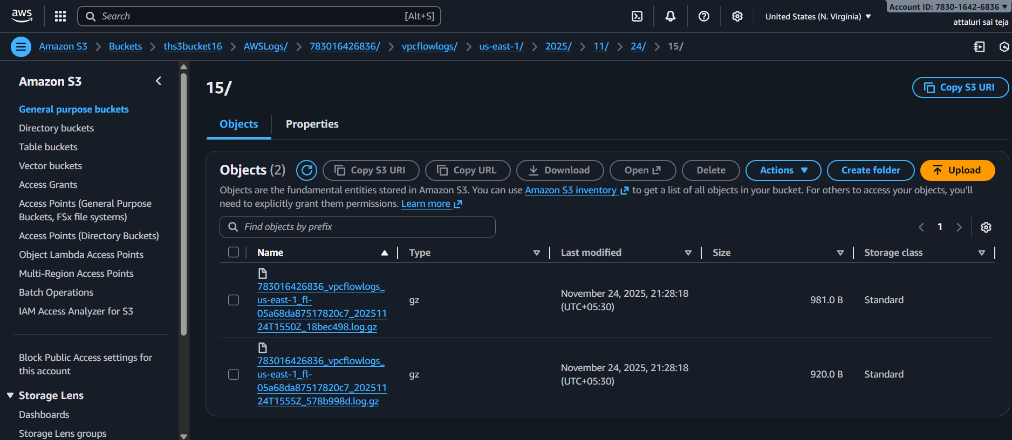
Creating cloud watch

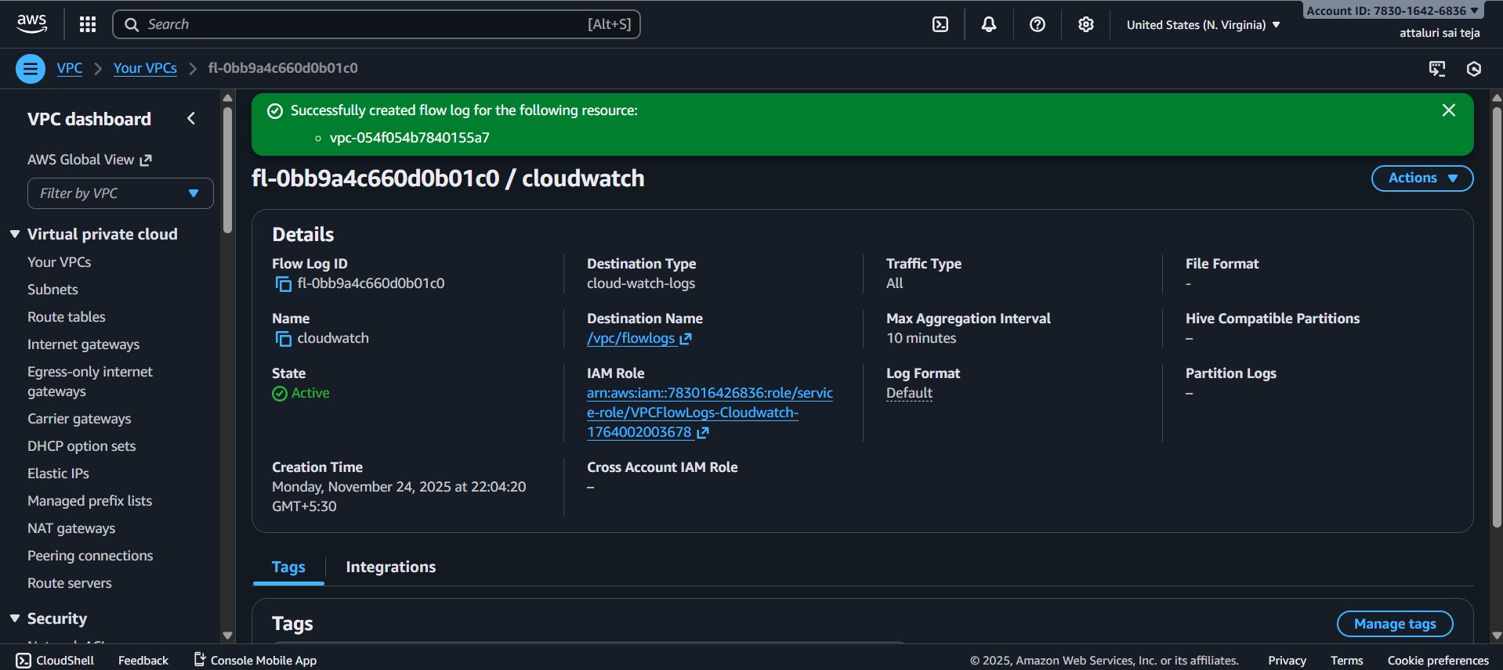

Navigate to vpcs section to list the logs
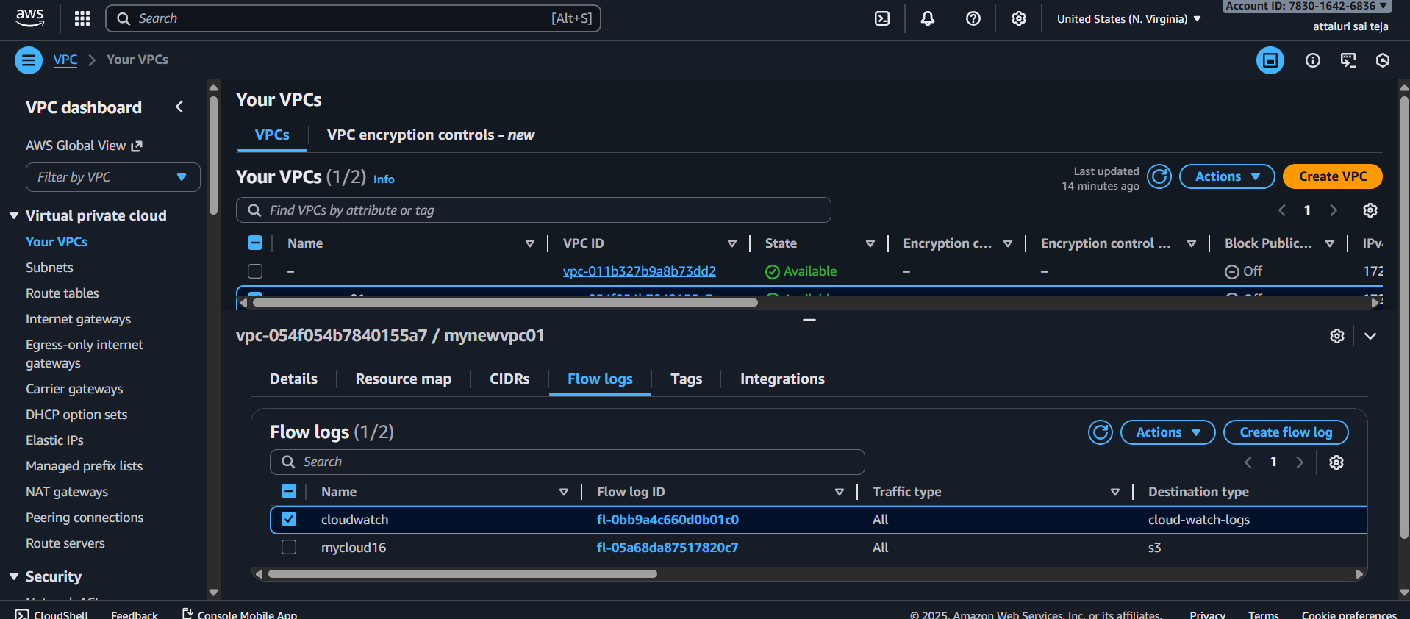
Navigate to log groups in cloud section list and logs will be displayed
